AEEC resubmission process

When a project is stopped at the administrative review, the project leader automatically received a notification from Service Now (“SNOW”), as per below example
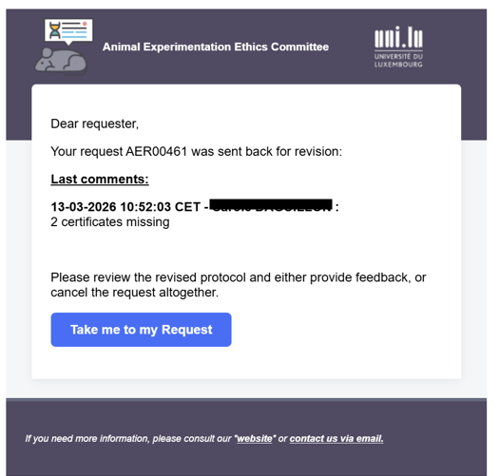

The failed back reason is specified in the email , under “last comments” (in this example, 2 certificates were not included)
The same failed back reason can also be retrieved in SNOW.
Click on “Take me to my Request” in the email to automatically open the project in SNOW.
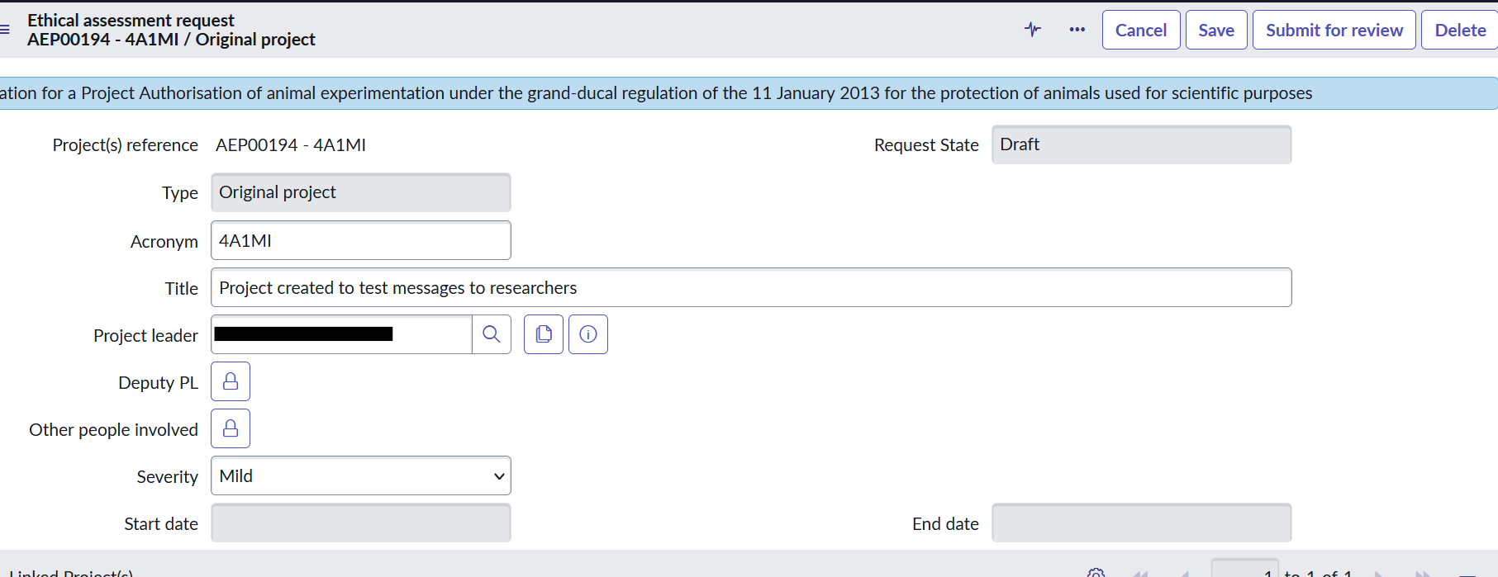

Scroll down to see the tabs ”admin follow-up” and “notes”.

Select “Notes” to see the historical activity of the project in SNOW.

The most recent activity is on the top.

The failed back is evidenced by “Request State: Draft , was Submitted”.
The reasons for the failed back is indicated in the first field (in this example “2 certificates missing”)

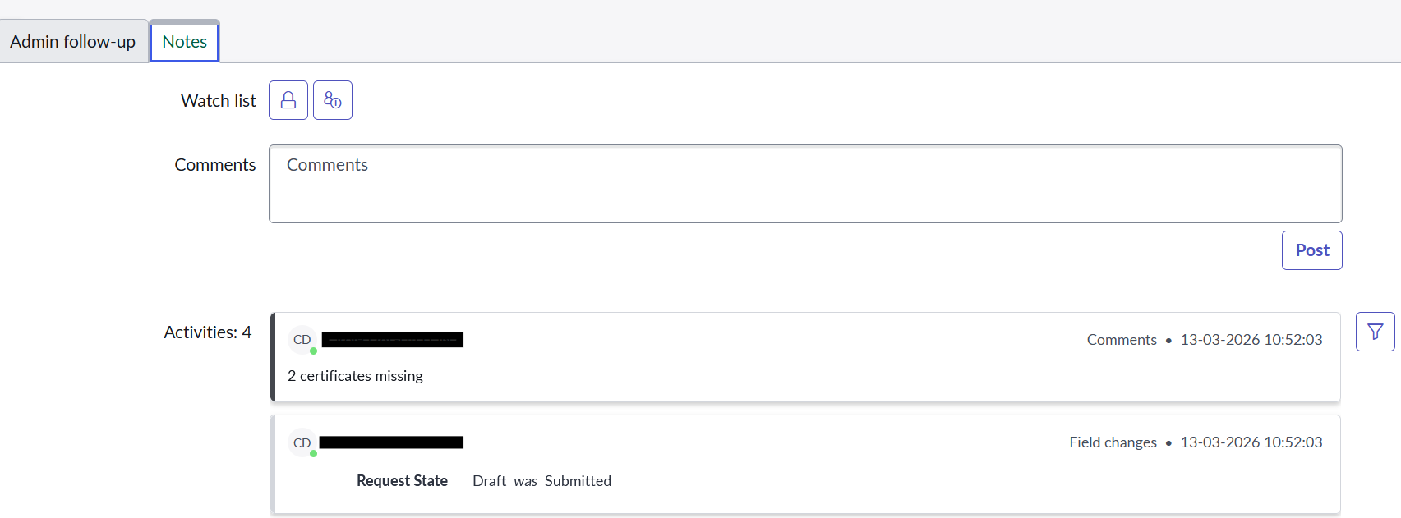
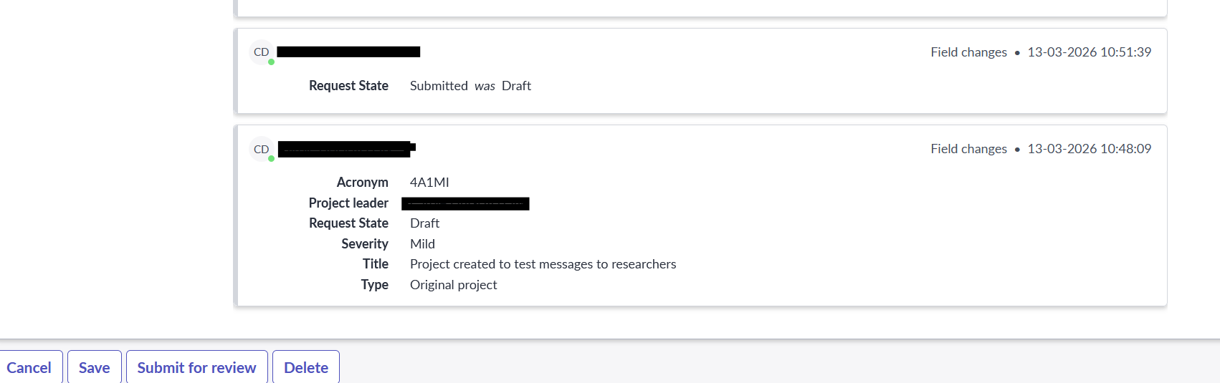

Proceed with the required changes (update or add documents) as per the first submission.
Once done, click on “Submit for review” to notify automatically the AEEC secretary of the changes made.

Caution: if the changes are done and saved without clicking on “submit for review”, the secretary will not be informed that the modifications have been achieved, meaning that the changes will not be reviewed by the committee and the approval process will be delayed!

