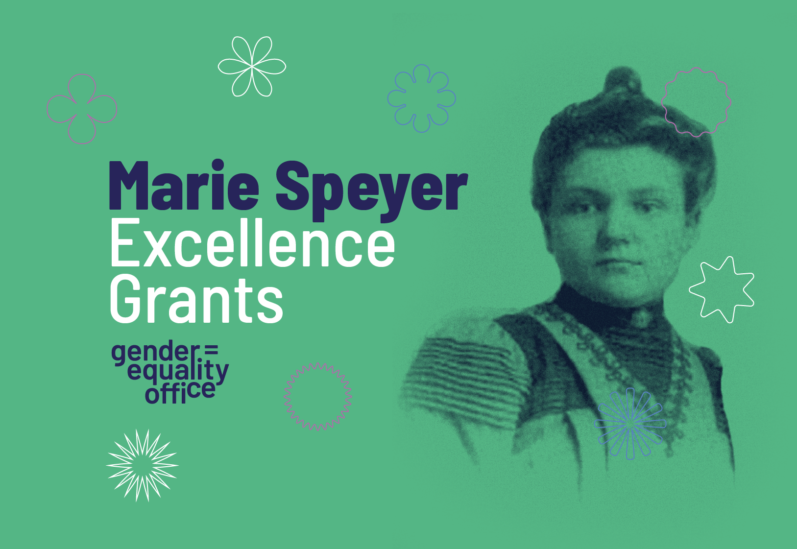

2026 MSE Application Form

How to proceed:
- Save this form using a standardized file name and complete all the sections:
2026-MSE_ProjectACRONYM_PI LastName_PI FirstName
- Proposals must be written in English with a fixed number of pages. Font Arial, size 11, single line spacing and 1.5 cm top/bottom/left/right margins must be used throughout the entire document. Proposals that do not follow his instructions will be rejected.
- Please remove this first page and the instructions in grey, before turning the final document into a PDF-file. The final project proposal must start with the following page of this document.
Also don’t forget to:
- Create, submit, and gather the approvals for your project using the online submission tool – ePAS: Research Support.
- Complete the institutional validation form and send it together with your project proposal for institutional validation (deadline: 29 January 2026)

Institutional validation deadline: 29 January 2026
Submission deadline: 2 February 2026 – 14h CET

For further information please the webpage:
Marie Speyer Excellence Grants - University of Luxembourg I Uni.lu
And/or contact the MSE team at: mariespeyer.grants@uni.lu

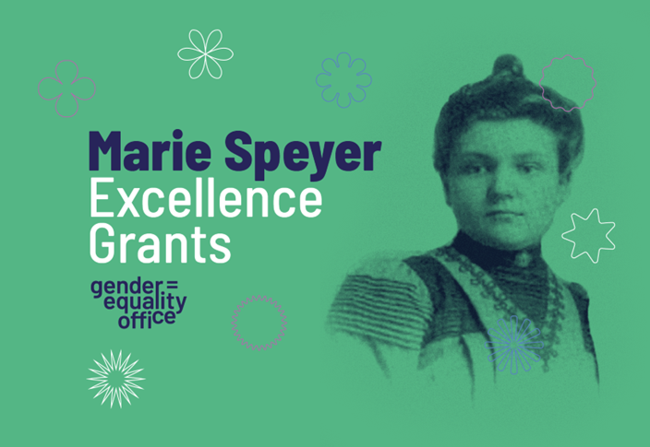
2026 MSE
Application Form

PROJECT ACRONYM
PROJECT TITLE

Applicant (Principal Investigator, PI)
Last NAME, First Name:
Title, Position:
Type of contract (if CDD please enter end date)
Faculty or Interdisciplinary Centre:
Department:
Keywords:
E-mail:

Project
Starting date
Duration (months)
Budget (€)
Recruitments (PhD, postdoc, other)

Project Description

Abstract (max. 0.5 page)
Describe the main idea of your project.
The abstract should be concise, clear, informative, and self-contained.

State-of-the-art, including your own relevant previous work (max. 1 page)
- Describe the current scientific state of the art and ongoing developments in fields relevant to your proposal, including your own previous work.
- Include available theories, concepts, or solutions, as well as conclusions (possibly with literature references).
- Provide an assessment of research needs (the main conclusions leading to the proposal).

Project description and objectives (max. 2 pages)
- Describe how the grant will help research in the corresponding field.
- If applicable, describe the potential use of the results after the grant.
- Outline your project’s contribution to the research needs.
- Clearly define the goal, objectives, focus, and scope of the project in a realistic and as far as possible, measurable form.
- State the main research questions and/or hypotheses to be addressed.

Project plan (max 2 pages: 1 page of text and a Gantt chart on a second page)
The project plan is illustrated by a Gantt chart (format of your choice), and describes the work planned in work packages, including, if applicable, the progression of the doctoral fellow(s). It also provides brief argumentation on how the work packages articulate and the structure of the main steps and tasks involved to achieve the project results.
The project plan must include a description and short justification for the requested costs; the detailed budget is an internal document that will not be shared with the evaluators.

Project outcomes and follow-ups (max. 0.5 page)
Contribution to the advancement of knowledge and Uni.lu’s research community. Describe the project’s contribution to knowledge production and how the results are exploited and disseminated within the research community. That is, how the project outcomes contribute to (1) the promotion of research across Uni.lu, (2) advancement of the state of the art, (3) the development of the scientific community, and the Uni.lu and its entities in terms of capacities, competencies, visibility, and attractiveness.
If applicable, describe how the research project will contribute to knowledge generation and the future of society. Describe what efforts (publications and other activities) are foreseen to increase public awareness, well-being, and understanding of the research field.
Future research plans. Indicate how the results of the project can form the basis for future research and what the plans are (depending on the results) for future grant applications to Uni.lu external funding institutions.
Exploitation and dissemination of research results. Please explain the measures that will ensure exploitation after the end of the project.

References (max. 0.5 page, font can be 10)

Legal and ethical requirements (max. 1 page)
Are data protection issues expected? | Y/N
Are agreements or approval required?
Additional comments
Are intellectual property right issues expected? | Y/N
Are agreements with partners required?
Additional comments
Are ethical issues expected? | Y/N
Are agreements or approval required?
Additional comments

Curriculum Vitae of the PI
Please complete the CV part of this form with information relevant to this application, max 5 pages.

Personal Information
Full name of the candidate
Researcher unique identifier (ORCID, Research ID, ...)
Nationality
Current address
Website (if any)
Email address
Telephone number
Education (starting from the most current)
DD/MM/YY - DD/MM/YY: Unit/Department/Faculty/University/Country
…
Professional experience (starting from the most current)
DD/MM/YY - DD/MM/YY: Position - Department/Institution/Country
…
Relevant invited presentations/lectures
Mention the title of the lecture, the conference/school and the year.
…
Scientific communications (posters, oral communication, etc.)
Mention the title, the type, the conference/event and the year.
…
Research visits and/or major collaborations
Mention dates, host/partner institution(s), country(ies), main topic, and/or purpose
…
Organisation of national and/or international conferences
Mention the date, event type & name/participant number/country. Explain your role.
…
Major achievements
Explain any significant achievement (e.g., science & innovation-related, business & society-related).
…
Relevant Prizes and Awards
DD/MM/YY: Award name & amount (if applicable)/Awarding authority/Country
…
Funding record (past, current, pending)
Describe the nature of the project, your role (Principal Investigator, partner etc.), the overall amount granted/applied for, and the funding agency.
…
Relevant supervision activities
DD/MM/YY - DD/MM/YY: Department/Faculty/University/Country
…
Relevant advisory, managerial, and service responsibilities
DD/MM/YY – DD/MM/YY: Describe the nature of the responsibility.
Commissions of trust (e.g., advisory board in research projects, reviewer in scientific journals).
…
Relevant membership in scientific societies/networks/associations
DD/MM/YYYY – DD/MM/YYYY: Mention the name of the Society/Networks
…
Publications (peer-reviewed journals & conference proceedings, monographs, books, book chapters, etc.)
List your relevant publications (in chronological order, most recent first).
…

