**Non-Technical Summary “NTS” User manual - version 10/2020**

Contents

1. Link to the system 2

2. Sign in or create EU Login 2

3. One time registration in DECLARE 3

4. Registration of Member State administrators 4

5. Registration of Competent authorities 4

6. Register a Competent authority organisation as an MS admin 4

7. Add a member to the Competent authority as an MS admin 5

8. Create a web service account for machine-to-machine communication 6

9. Self-register as a Project applicant organisation 7

10. Approve pending registration of Project applicant organisation 8

11. Information sharing between the members of the same organisation 8

12. NTS workflows overview 9

13. Create an NTS using a web-form 10

14. Submit an NTS as a Project applicant to the Competent authority 11

15. Create an NTS using an excel file 12

16. Approve NTS as a Competent Authority for Project Evaluation 13

17. Publish an NTS as a Competent Authority for Project Authorisation 14

18. Request modification of the NTS 15

19. Useful links and contact info 16

# Link to the system

The real data is submitted using a system called DECLARE/ALURES at: <https://webgate.ec.europa.eu/declare/>

DECLARE/ALURES playground for testing purposes is at:

<https://webgate.acceptance.ec.europa.eu/declare/>

In order to submit data through the system, you must be registered in DECLARE/ALURES.

In order to test the application, you must be registered in DECLARE/ALURES playground.

# Sign in or create EU Login

When you access the link of DECLARE system, you are re-directed to “EU Login” *(European Commission login system)* to sign in or to create a new account (if you don’t have yet any)

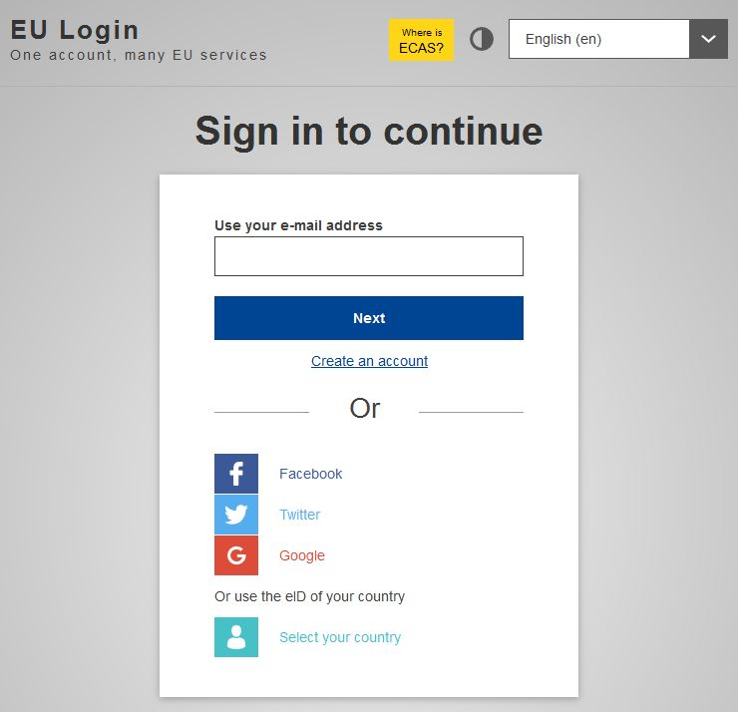

# One time registration in DECLARE

Every user has to register himself into Declare the first time when he access the system. This is one time action.

The information submitted in EU Login will be automatically used by the system for the purpose of registration in DECLARE.

Once logged into EU Login, you access DECLARE performing the following steps:

1. Select ALURES policy domain to enter into the system

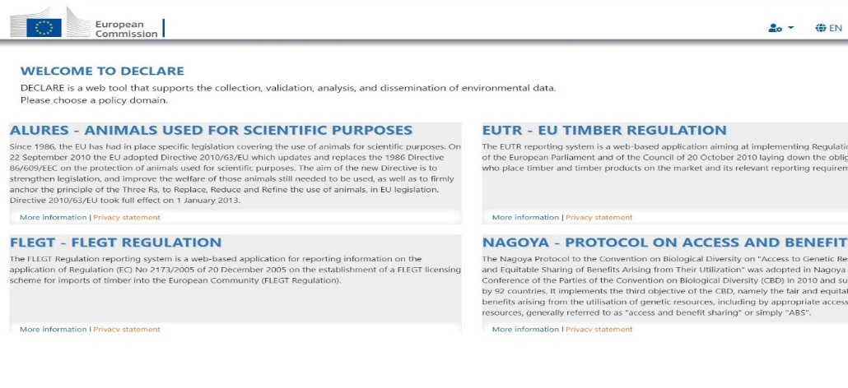

1. Register your account into the system

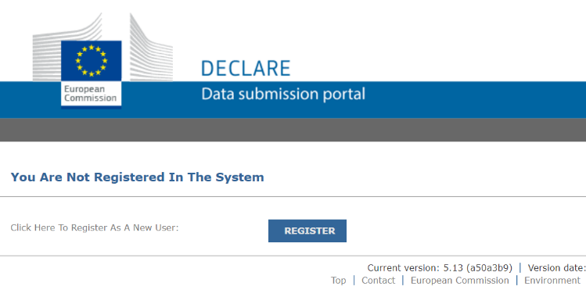

1. Read the privacy statement and terms and condition of the usage of the system

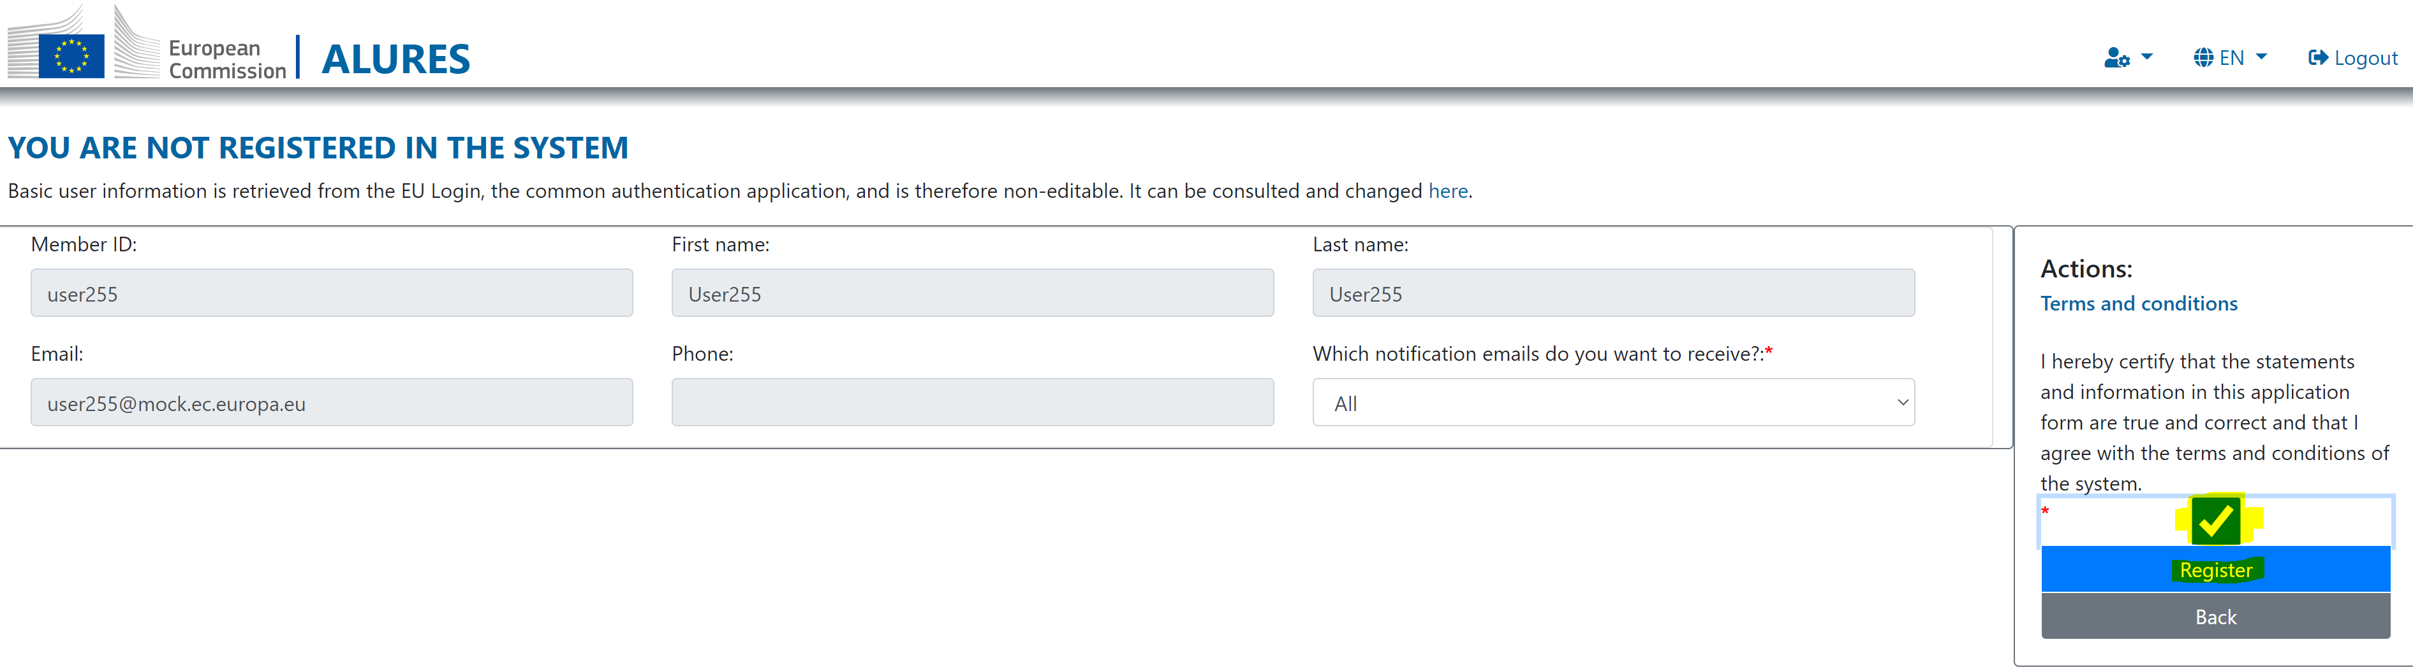

# Registration of Member State administrators

European Commission registers ‘Member State’ organisation and its initial member as an “administrator”. Member State admin can then register Competent authorities in her/his country.

# Registration of Competent authorities

Member State administrator can register any number of Competent Authority organisations.

Any number of members can be added to each Competent Authority organisation. Each member can have ‘Competent Authority for Project Evaluation’ (CAPE) or ‘Competent Authority for Project Authorisation’ (CAPA) role. Where the same person is responsible for both - evaluation and authorisation, MS administrator will add the same user twice with different roles.

Below is the example of how Member State organisations and users could be organised.

# Register a Competent authority organisation as an MS admin

1. Click the menu item ‘Register new organisation’

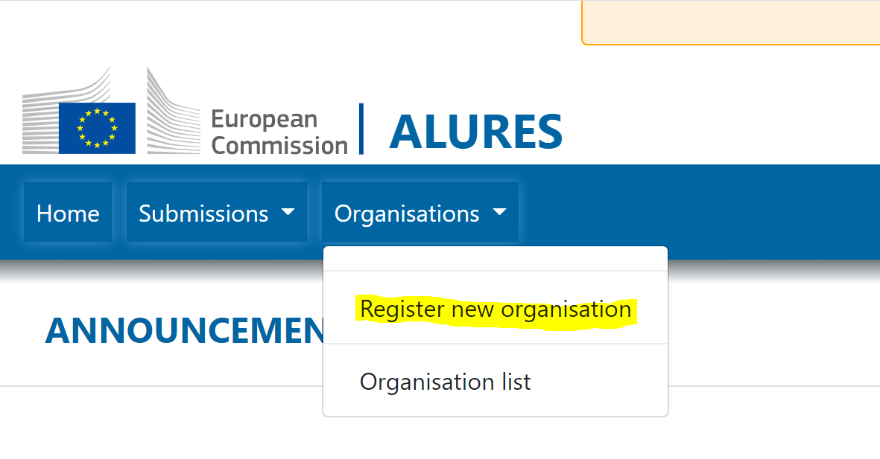

1. Choose ‘Competent Authority’ as organisation type, fill in organisation name, location and captcha text and click ‘Register’

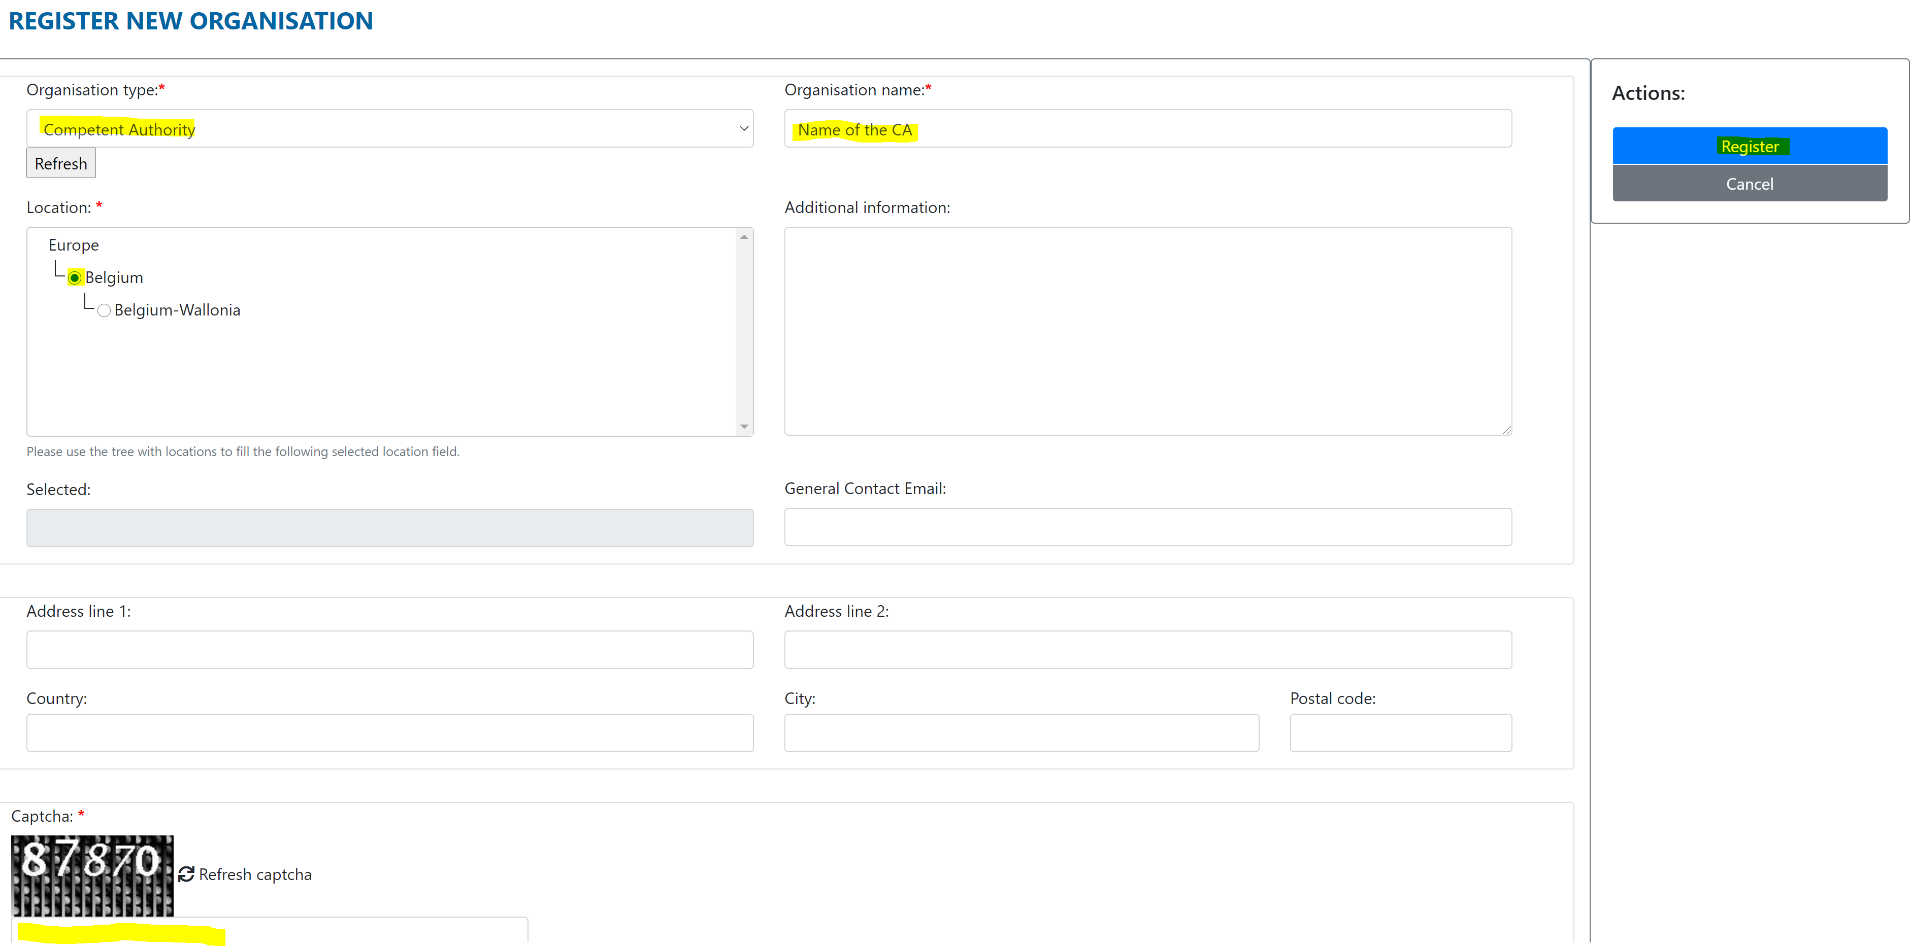

1. Activate the organisation

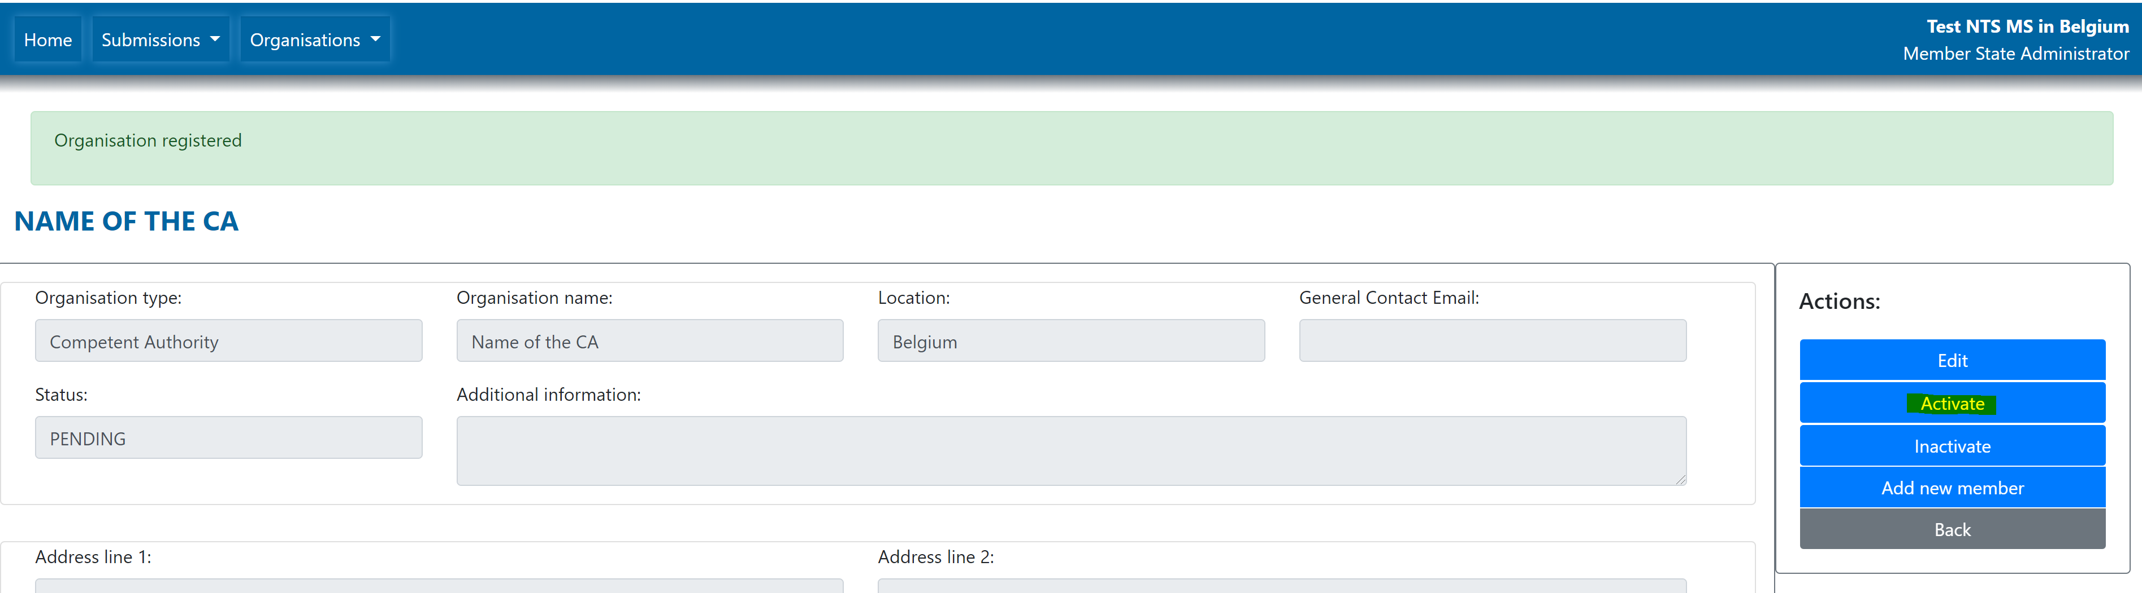

# Add a member to the Competent authority as an MS admin

1. Click the menu item ‘Organisation list’

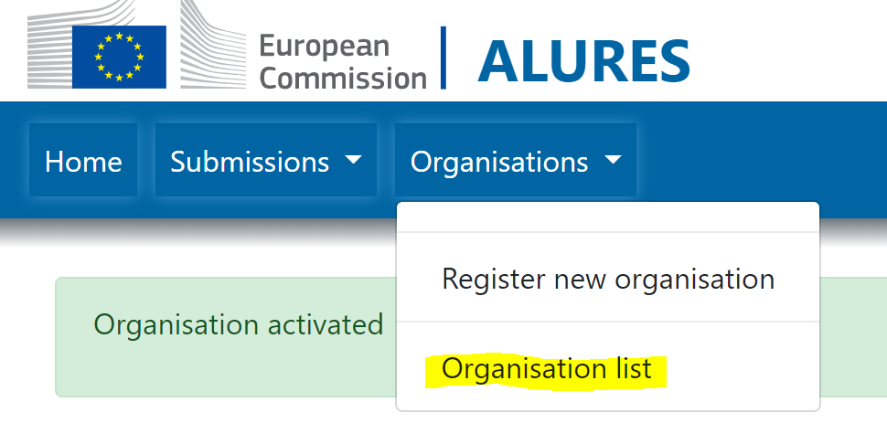

1. Click on the row with chosen organisation to see organisation details
2. Click ‘Add new member’

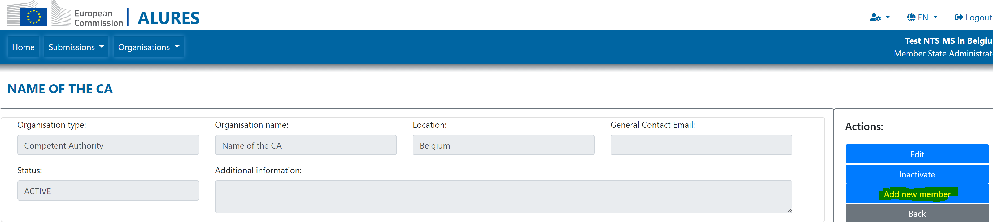

1. Choose the role, fill in the email address and click ‘Add new member’

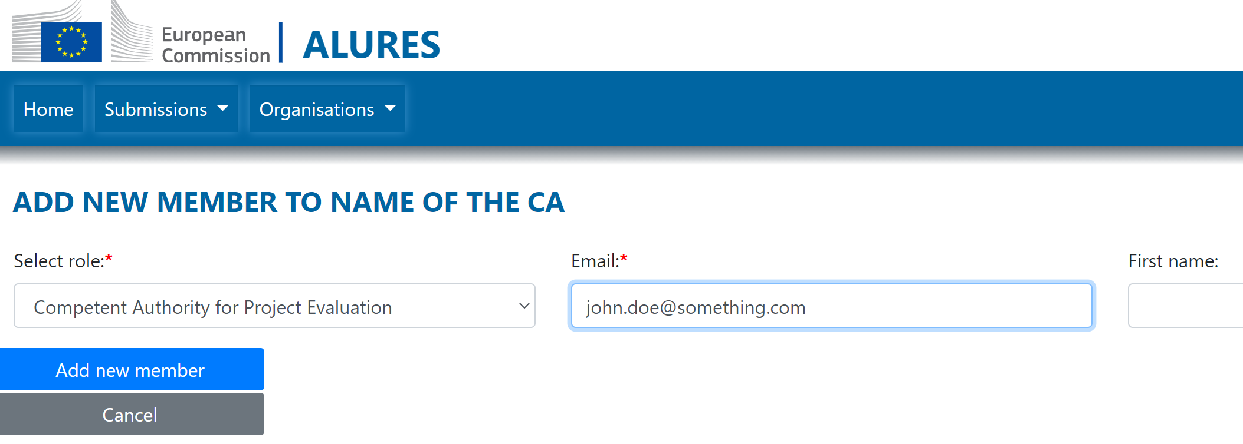

Note: the email address in Declare must match user’s EU login email address

# Create a web service account for machine-to-machine communication

Only the user with ‘Competent Authority for Project Authorisation’ (CAPA) role has permission to publish NTS. Once the human user with CAPA role is registered in Declare system, she can create her web service account to be used by national system to publish NTS into Declare.

1. Login into Declare as ‘Competent Authority for Project Authorisation’. If you have more than one role, **make sure you set CAPA as your current role**.

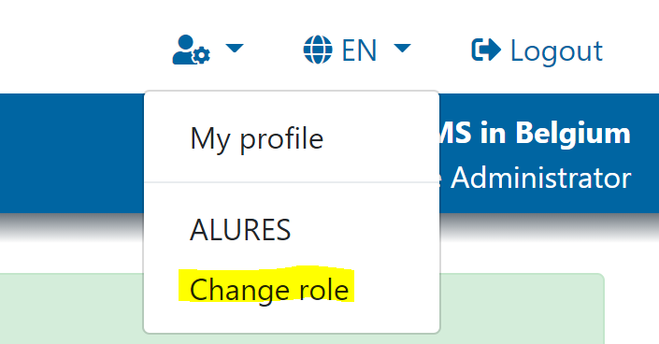

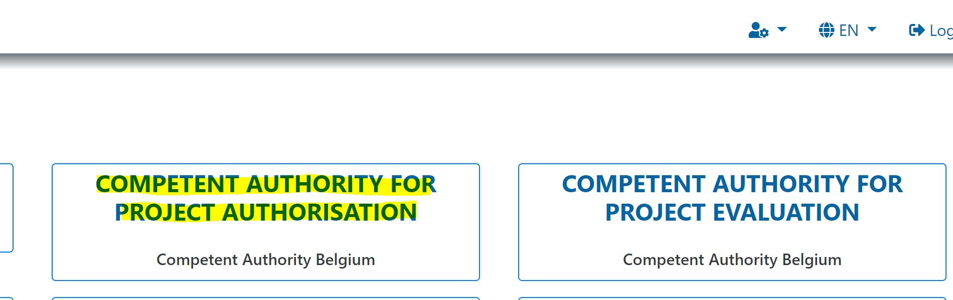

1. Click ‘My profile’ menu item

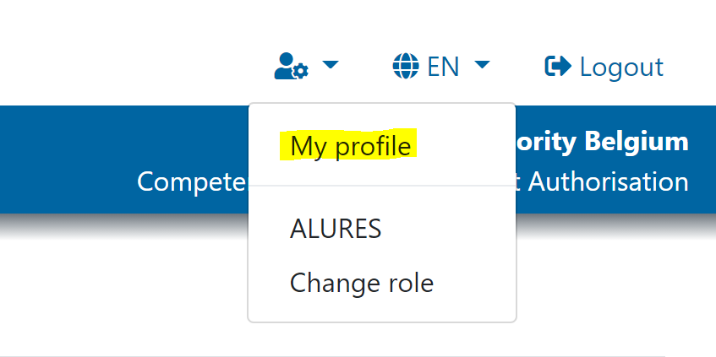

1. Click ‘Add new web service account’

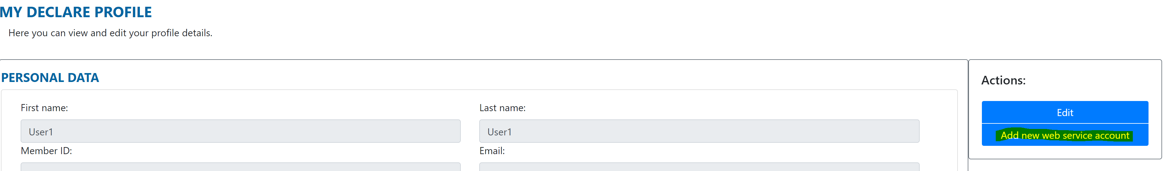

1. Enter a password to be used for web service account and click ‘Save’

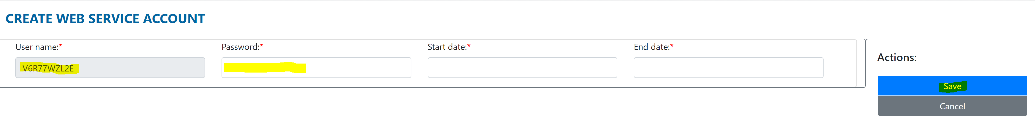

With automatically created user name and password you have provided, your national system can access Declare NTS web service in order to publish NTS.

# Self-register as a Project applicant organisation

Project applicants can **self-**register. In order to activate self-registered project applicant, the Competent authority has to approve the registration.

Once you have successfully registered in Declare, you can register your organisation as a ‘Project applicant’ organisation - the entity on whose account the data will be provided. Organisation, university, company or laboratory is later called "Project applicant" in DECLARE.

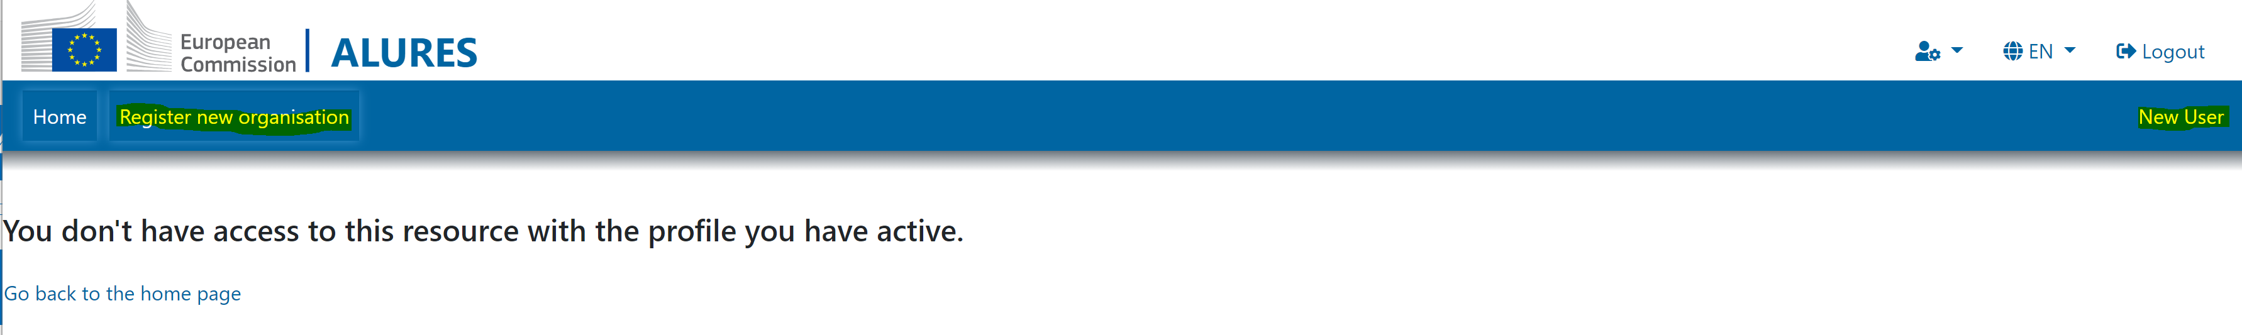

There are 5 mandatory elements on the form. Others are optional.

1. Select the organisation type “Project applicant”
2. Enter the name
3. Select the country of the Competent authority that will approve the registration
4. Enter “captcha”
5. Click on “Register” button

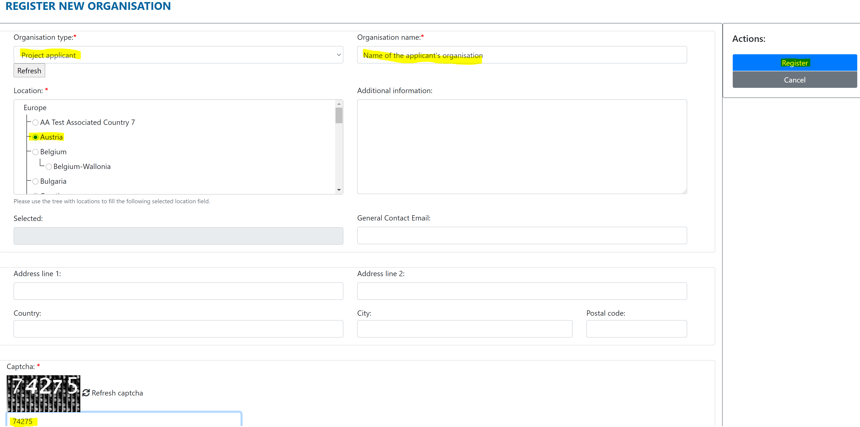

The registration form of the Project applicant will go in status “PENDING” and wait for validation by the relevant competent authority (a body designated for that purpose by the Member State).

After validation of the registration from, the user receives an email confirming that he/she has the access rights required to use DECLARE Alures and can submit data.

You will receive an e-mail notification when registration form is approved. If not, please contact your Competent Authority.

# Approve pending registration of Project applicant organisation

1. Click on the pending project applicant organisation on the ‘List of organisations’

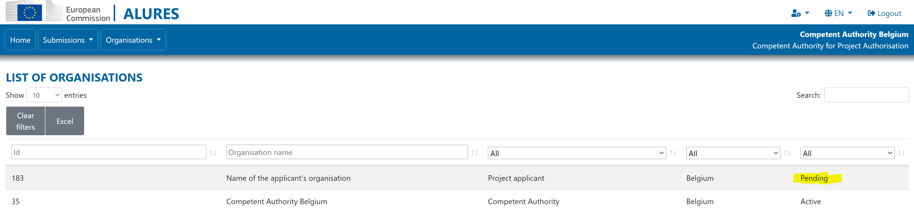

1. Click ‘Activate’

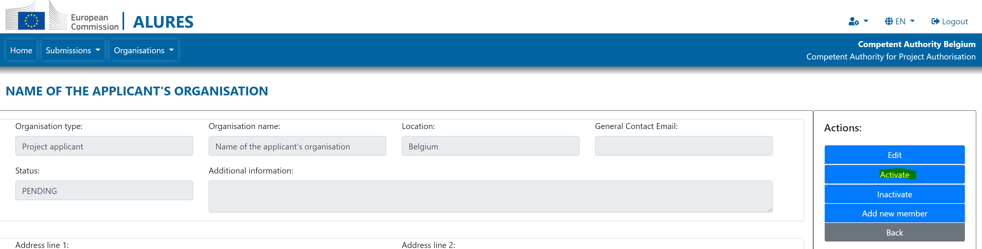

# Information sharing between the members of the same organisation

Every organisation can have as many members active in DECLARE as it wishes to.

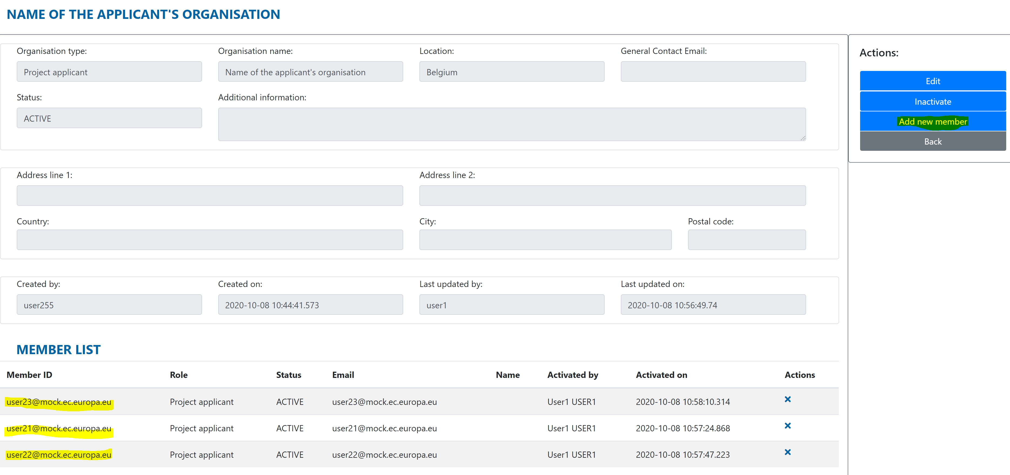

**WARNING**: Be aware that confidential information provided by members of one organization in DECLARE will be visible to all other members from the same organization. If a given organization wants to avoid such a situation, different departments should register as separate organisations, each with its own members.

Please note that each organisation (Project applicant or competent authority) **is responsible for member’s access rights**. It is equally important to ensure that **person(/s) who no longer should have access rights are removed promptly due to the fact that DECLARE/ALURES system contains sensitive data**.

Organisation access rights are managed under “Organisations”, “Organisation List”.

# NTS workflows overview

Declare ALURES NTS web application supports the following scenarios:

1. NTS is created and submitted by Project Applicant, approved by Competent Authority for Project Evaluation and published by Competent Authority for Project Authorisation
2. NTS is created by Competent Authority for Project Evaluation and then published by Competent Authority for Project Authorisation
3. NTS is created and published by Competent Authority for Project Authorisation

First scenario requires Project Applicant registration in Declare and can be realised only using an **NTS web form**.

Second and third scenarios can be realised either by using **NTS web form** or **NTS excel** upload.

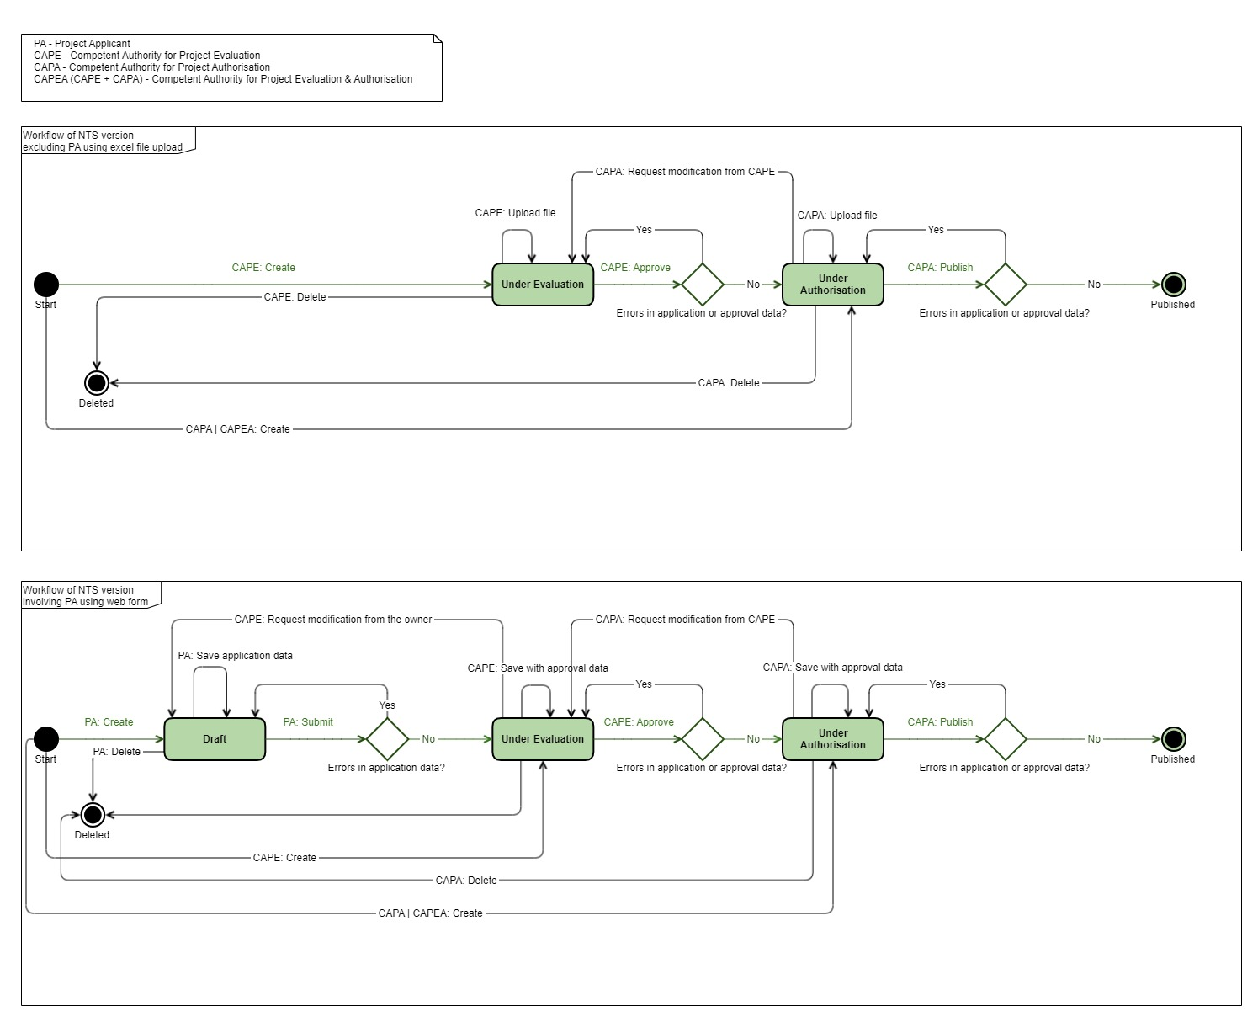

# Create an NTS using a web-form

Either project applicant (PA), project evaluation authority (CAPE) or project authorisation authority (CAPA) can create NTS web form. Resulting status and available actions will differ depending on the user’s role. Below instruction illustrates a case when project applicant is creating NTS herself.

1. Click ‘Submit data’ menu item or home page icon

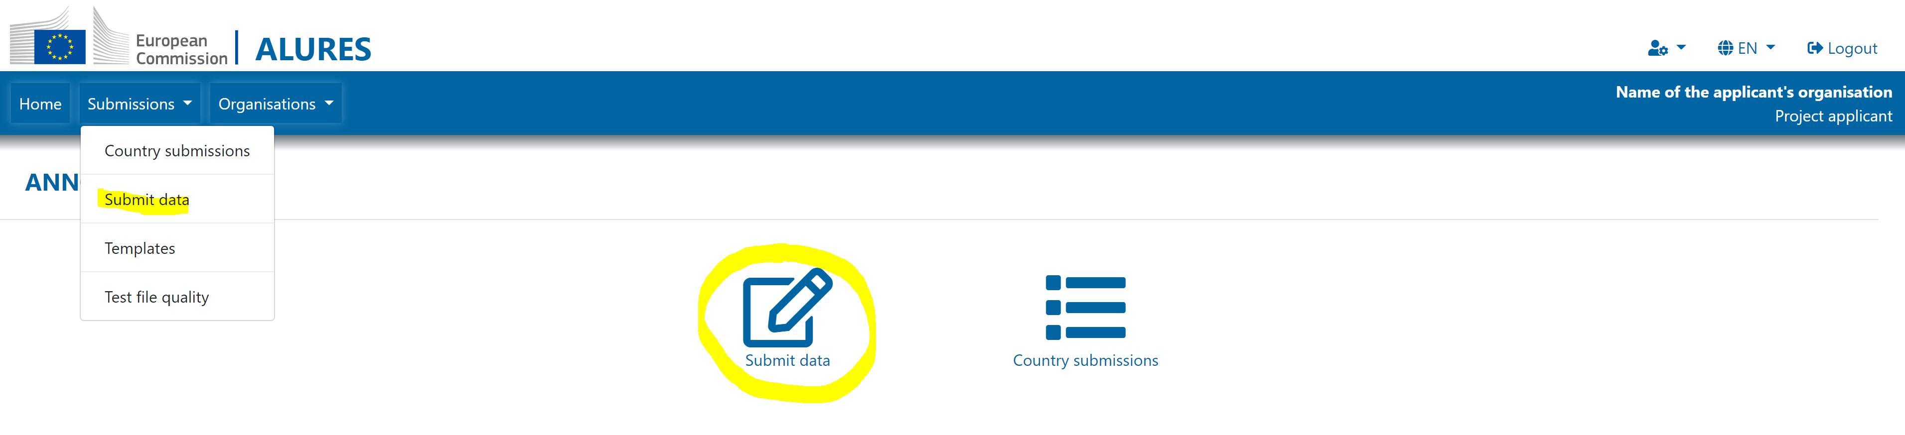

1. Choose ‘NTS form’ as a form type, fill in at least mandatory fields and click ‘Save’

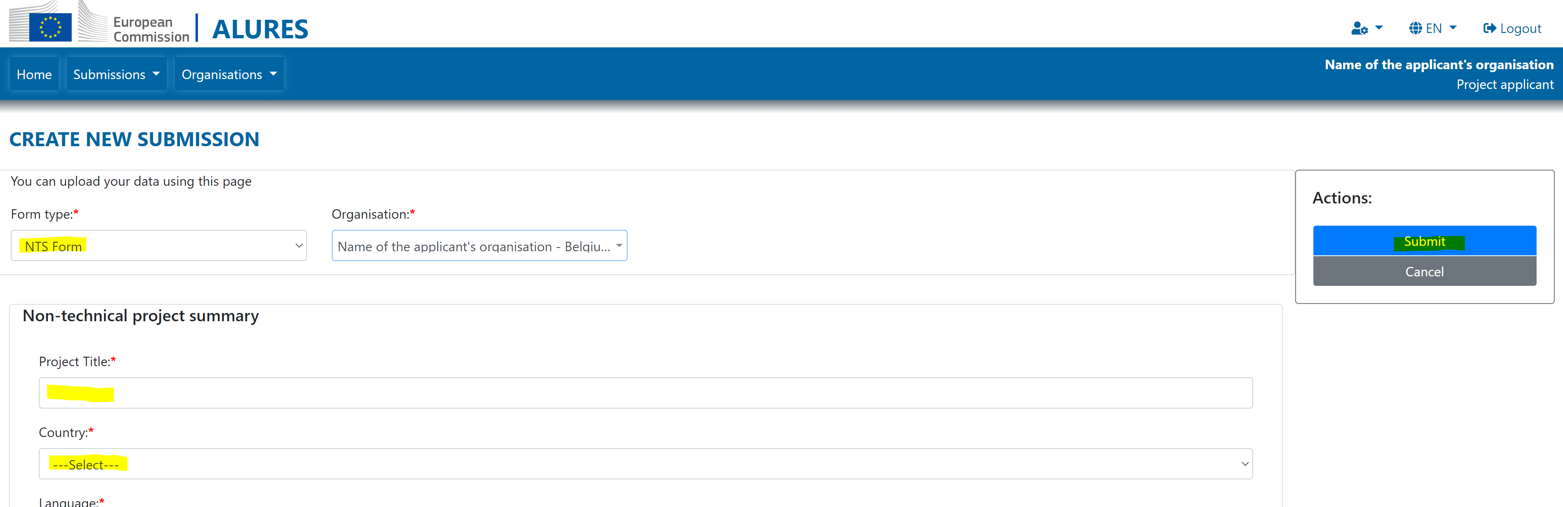

In case of invalid or incomplete data, system shows the error messages and user can continue to edit the form. Otherwise, system shows the success message.

System automatically assigns NTS identifier and initial status. The status NTS depends on the creator’s role:

* If PA creates NTS: initial status is ‘Draft’
* If CAPE creates NTS: initial status is ‘Under evaluation’
* If CAPA creates NTS: initial status is ‘Under authorisation’

# Submit an NTS as a Project applicant to the Competent authority

1. Click submissions menu item or home page icon

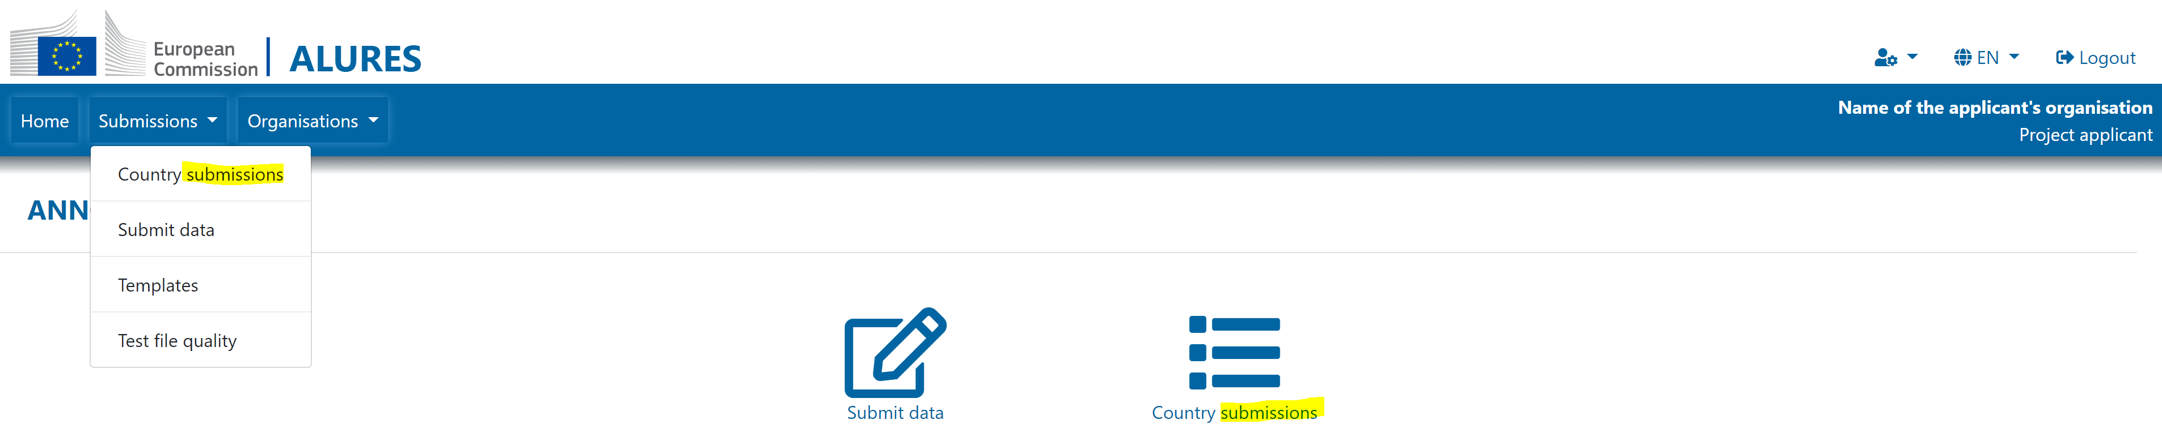

1. Click on the row with draft NTS

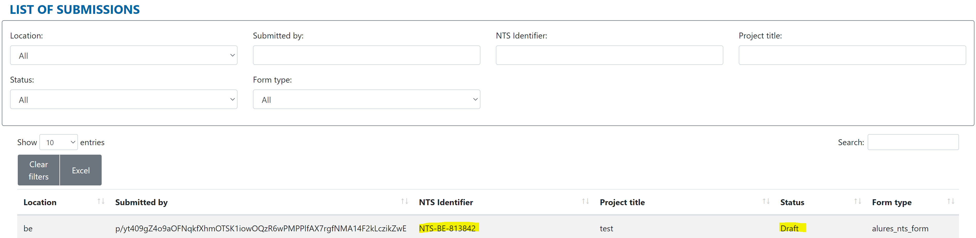

1. Click ‘Submit’

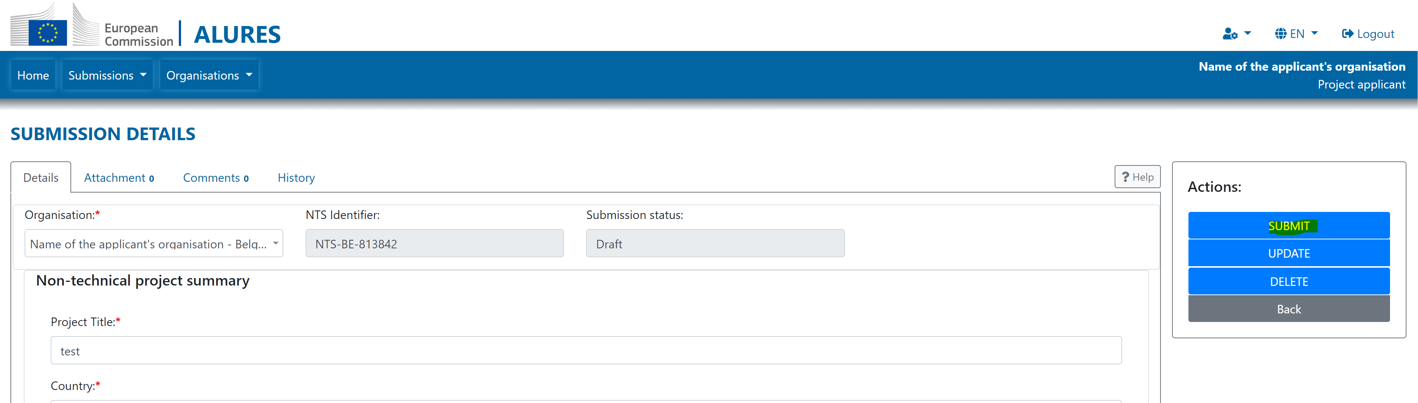

System assigns the ‘Under evaluation’ status. Once the PA submits NTS to a competent authority, NTS will be visible to all project evaluation authorities registered at the same location as the project applicant.

# Create an NTS using an excel file

Either project evaluation authority (CAPE) or project authorisation authority (CAPA) can create NTS using an excel file. Resulting status and available actions will differ depending on the user’s role.

1. Click ‘Submit data’ menu item or home page icon

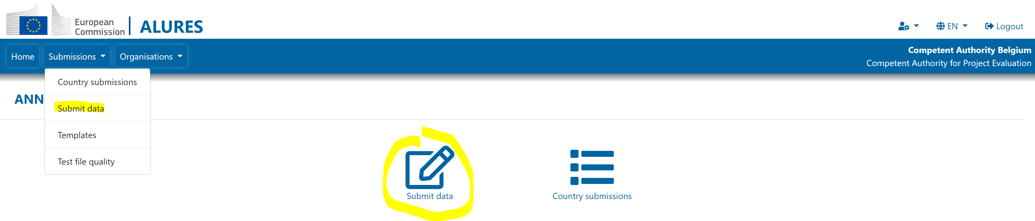

1. Choose the ‘NTS excel’ as a form type and click the ‘Browse’ button

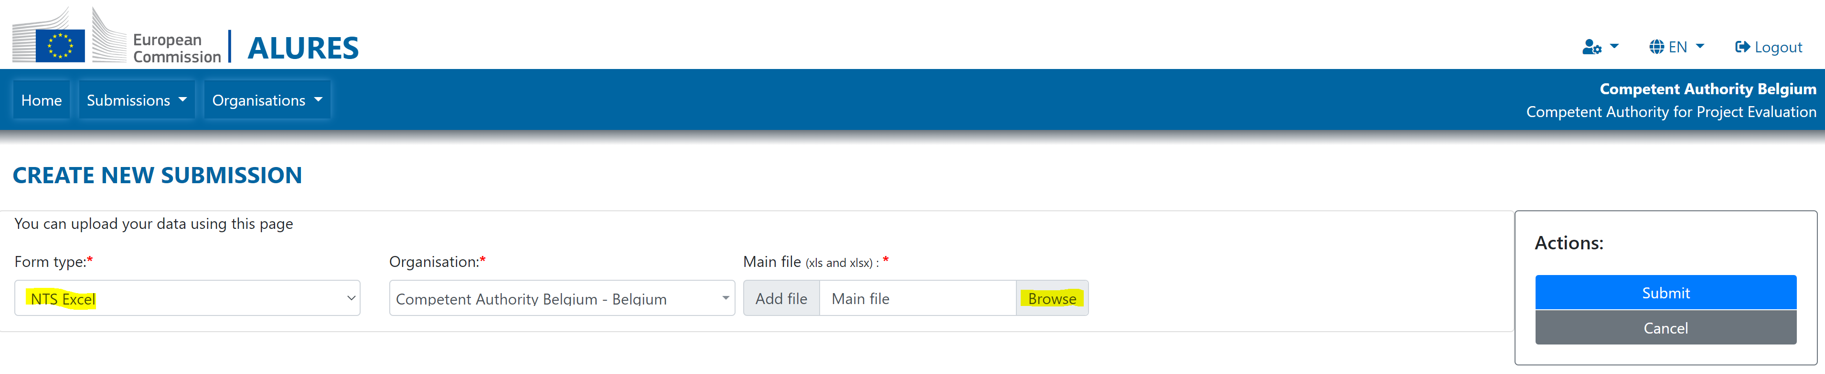

1. Chose the file to upload and click ‘Submit’ button

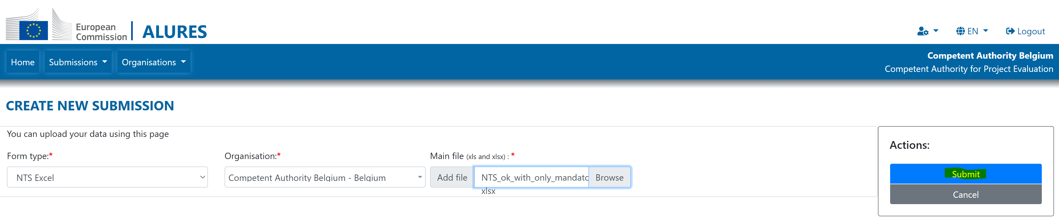

1. System will show the validation results and link to the validation report where you can see the detailed error(s) if any

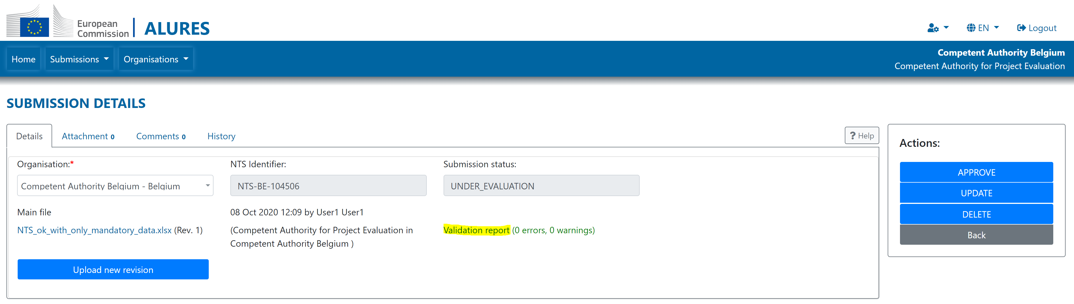

System automatically assigns NTS identifier and initial status. The status NTS depends on the creator’s role:

* If CAPE creates NTS: initial status is ‘Under evaluation’
* If CAPA creates NTS: initial status is ‘Under authorisation’

# Approve NTS as a Competent Authority for Project Evaluation

1. Click submissions menu item or home page icon

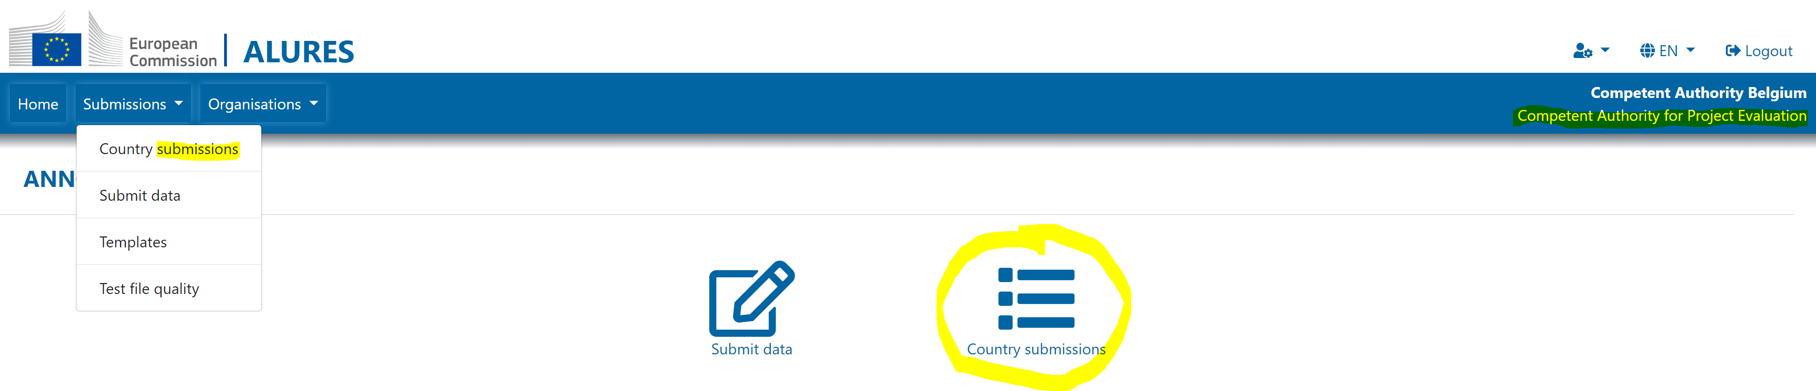

1. Click on the row with the NTS in the ‘Under evaluation’ status

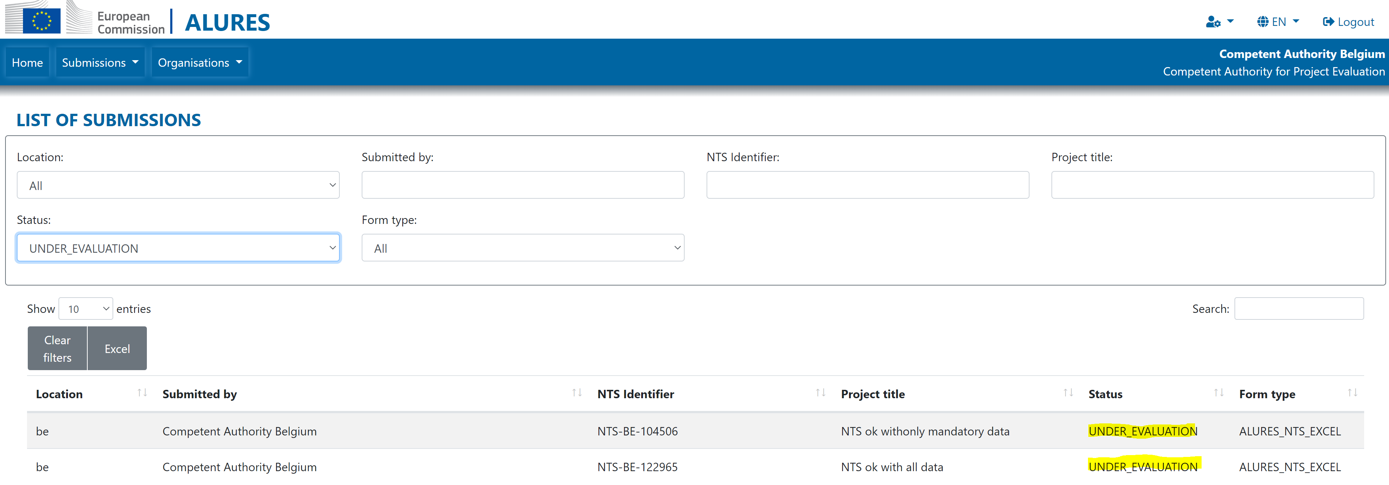

1. Click ‘Approve’

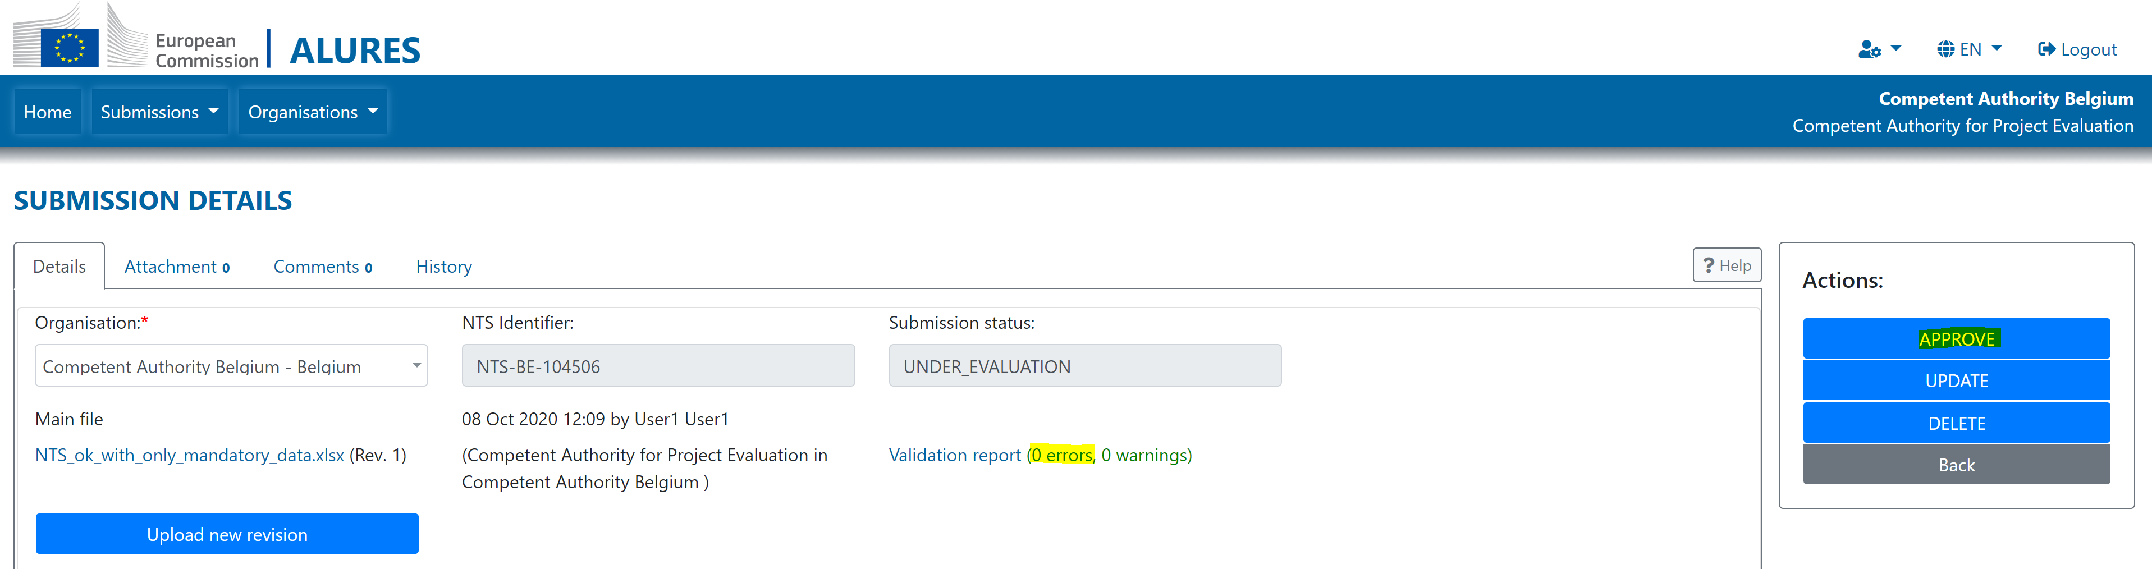

In order to approve the NTS, the excel file must not contain any error. In case of errors, upload corrected file by using the ‘Upload new version’ button.

Once the CAPE approves the NTS, the system assigns it the status ‘Under authorisation’.

# Publish an NTS as a Competent Authority for Project Authorisation

1. Click submissions menu item or home page icon

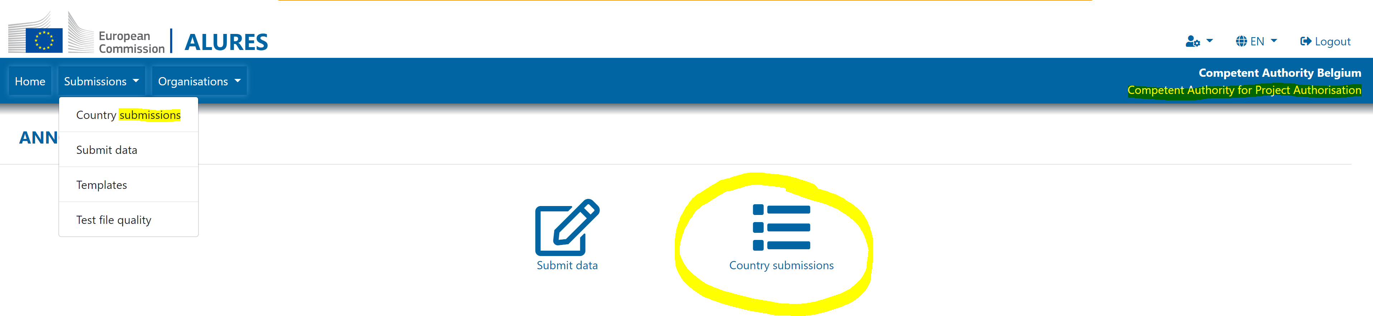

1. Click on the row with the NTS in the ‘Under authorisation’ status

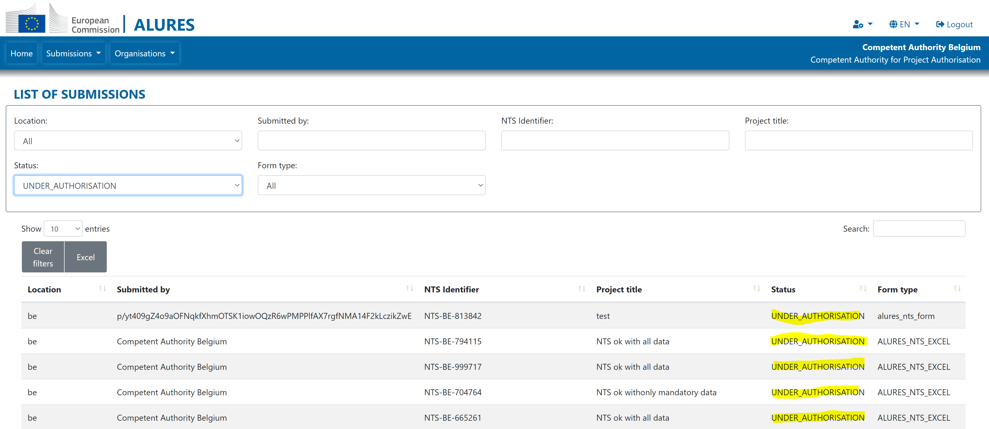

1. Click ‘Publish’

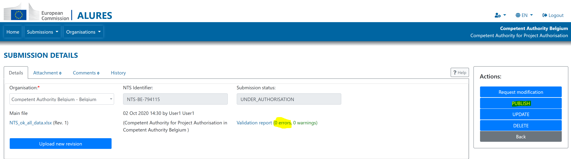

In order to publish the NTS, the excel file must not contain any error. In case of errors, upload corrected file by using the ‘Upload new version’ button or request modification from the CAPE.

Once the CAPA approves the NTS, the system assigns it the status ‘Published’.

Published NTS cannot be modified anymore without creating and publishing an amendment (new version of the NTS).

# Request modification of the NTS

As long as the NTS is in either ‘Under evaluation’ or ‘Under authorisation’ status, CAPE or CAPA can request modification from the previous process participant.

* For the NTS submission in the status ‘Under authorisation’, CAPA can request modification from CAPE.
* For the NTS submission in the status ‘Under evaluation’, CAPE can request modification from the Project Applicant. This option is available only for NTS web form, and it makes sense only if Project Applicant is registered in Declare, and is the ‘owner’ of the NTS. Ownership of the NTS is visible in the ‘Organisation’ field:

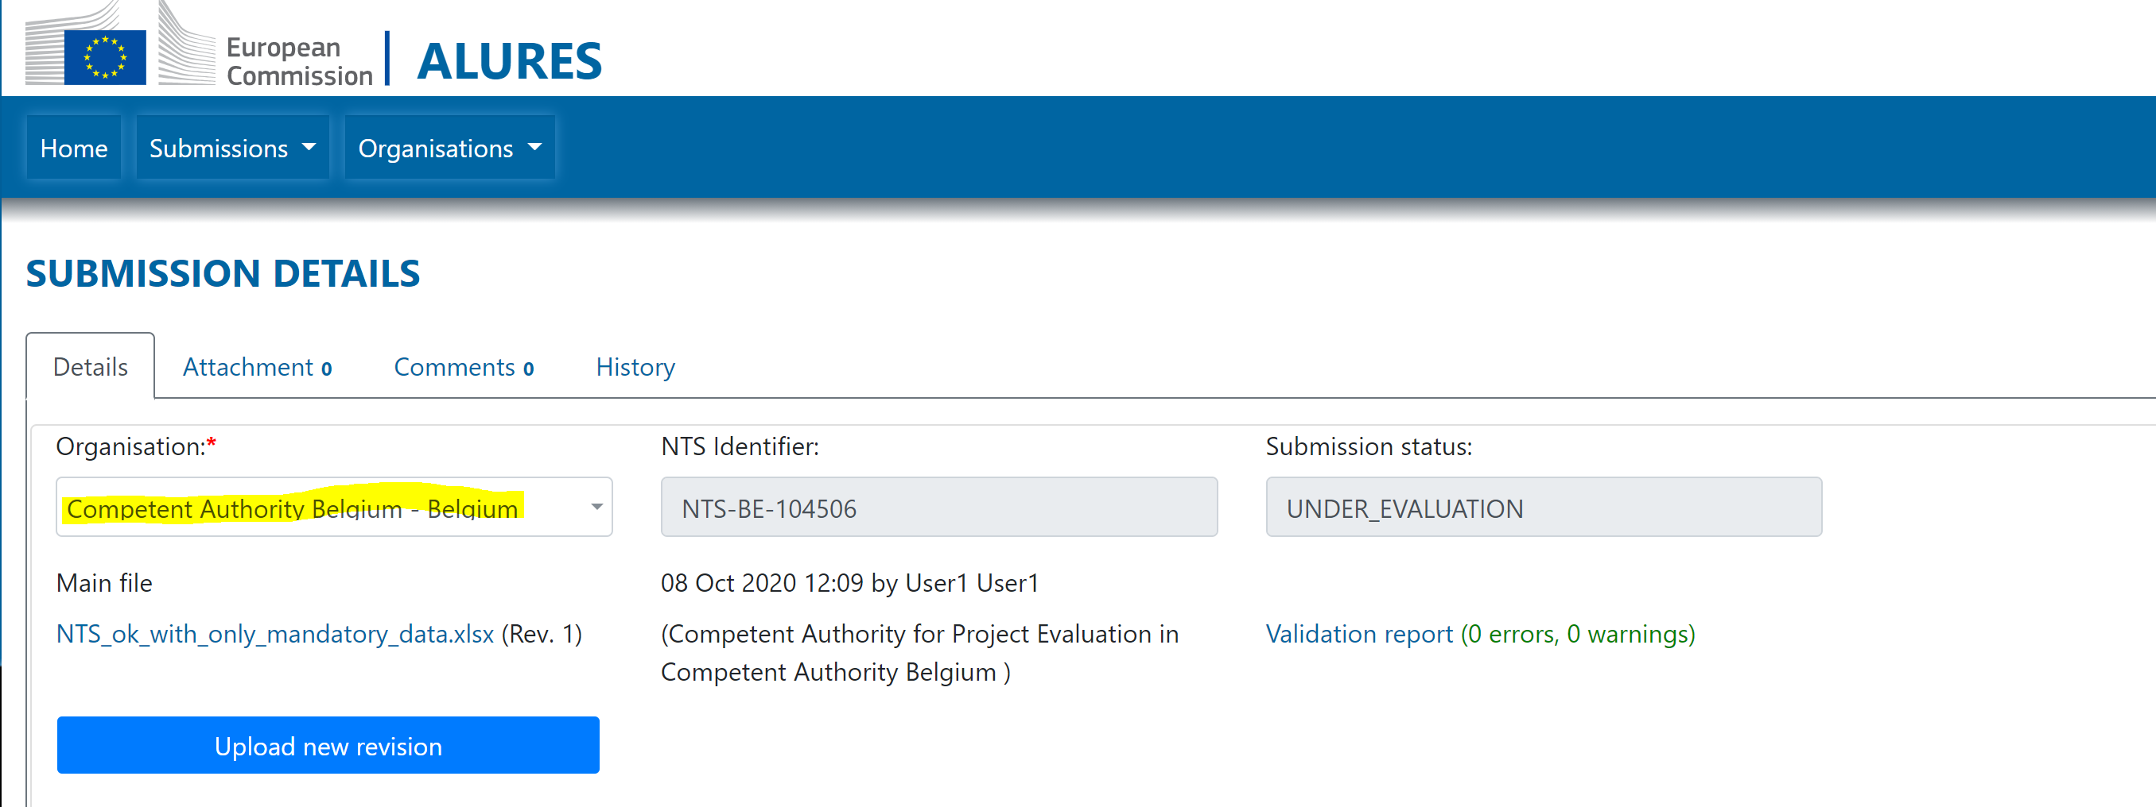

**To request modification**:

1. Add Comment or/and Attachment which explains what has to be checked or changed:

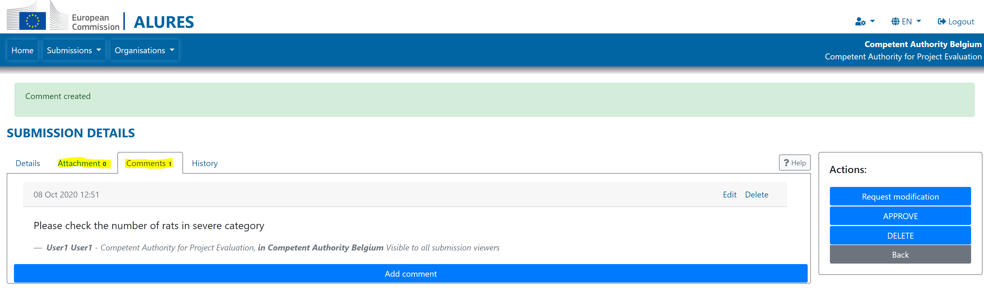

1. Click the ‘Request modification’

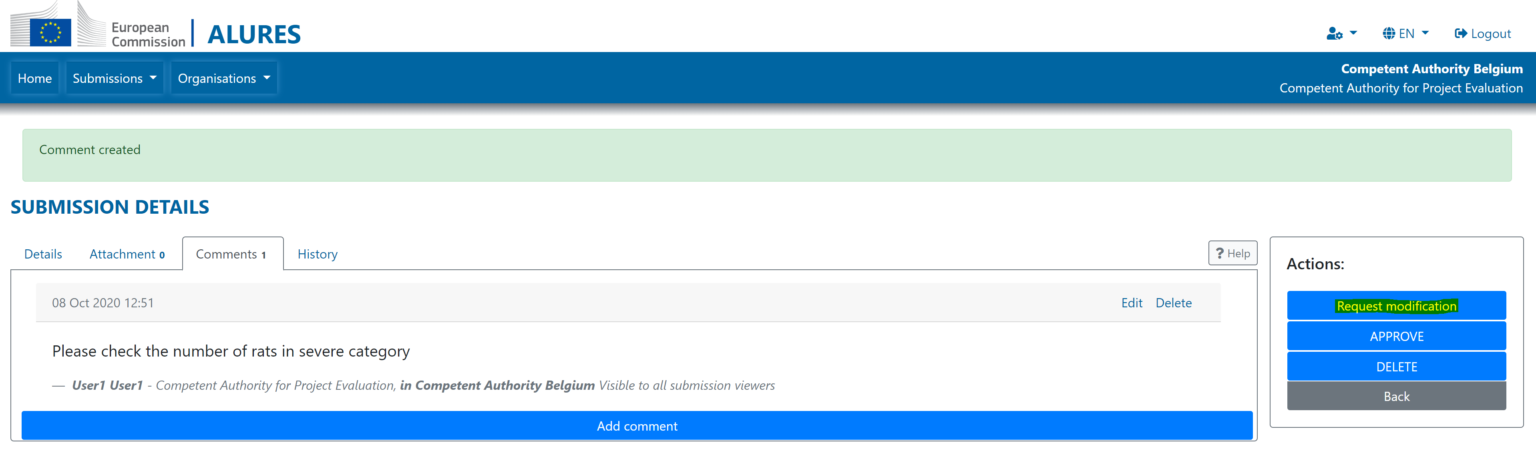

The system will automatically change the status of the NTS:

* ‘Under evaluation’ -> ‘Draft’
* ‘Under authorisation’ -> ‘Under evaluation’

# Useful links and contact info

* DECLARE/ALURES formal submission site: <https://webgate.ec.europa.eu/declare/>
* DECLARE/ALURES playground for training and testing purposes: <https://webgate.acceptance.ec.europa.eu/declare/>
* Document concerning DECLARE/ALURES are also stored in a restricted CIRCABC for National Contact Points under Directive 2010/63/EU at <https://circabc.europa.eu>
  + Select: Directive 2010/63/EU National Contact Points
  + See: Library > DECLARE_ALURES
* **Functional mailbox for any technical questions and/or problems:**   
  [ENV-DECLARE-ALURES@ec.europa.eu](mailto:ENV-DECLARE-ALURES@ec.europa.eu)