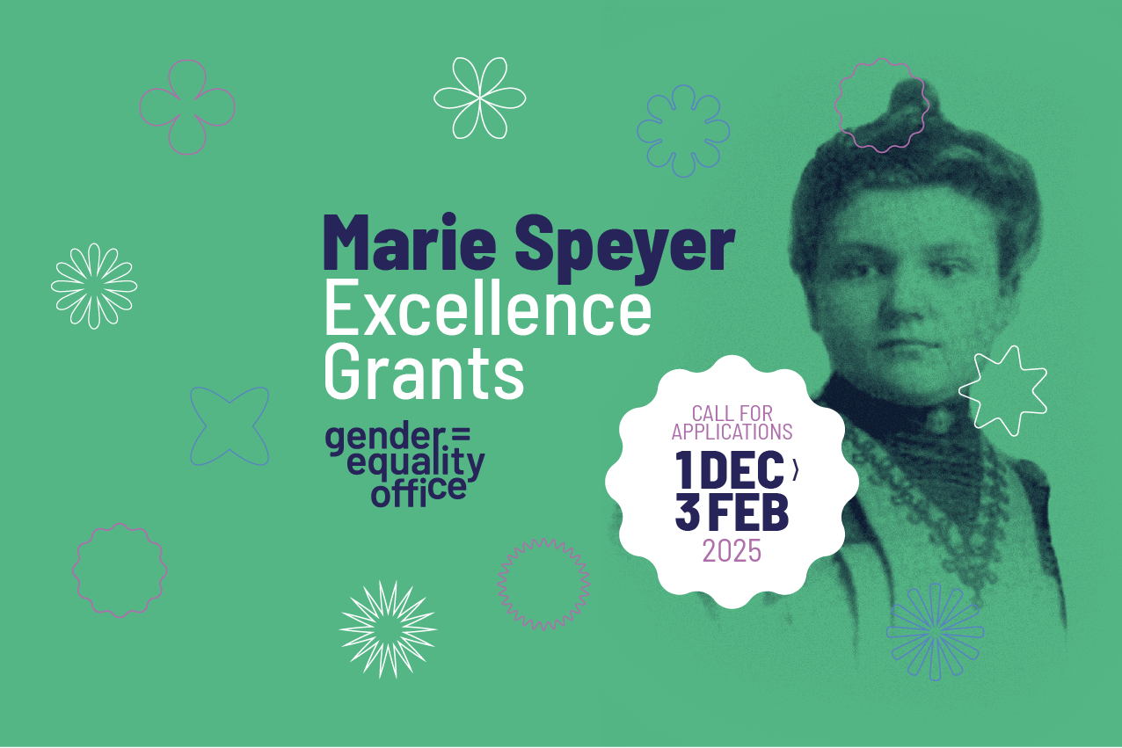

2025 MSE Application Form

How to proceed:
- Save this form using a standardized file name and complete all the sections:
2025-MSE_ProjectACRONYM_PI LastName_PI FirstName
- Proposals must be written in English with a fixed number of pages. Font Arial, size 11, single line spacing and 1.5 cm top/bottom/left/right margins must be used through the entire document. Proposals that do not follow his instructions will be rejected.
- Please remove this first page before turning the final document into a PDF-file. The final project proposal must start with the following page of this document.
Also don’t forget to:
- Create, submit and gather the approvals for your project using the online submission tool – ePAS: Research Support.
- Complete the institutional validation form and send it together with your project proposal for institutional validation (deadline: 27 January 2025)

Institutional validation deadline: 27 January 2025
Submission deadline: 3 February 2025 – 14h CET

For further information please the webpage:
Marie Speyer Excellence Grants - University of Luxembourg I Uni.lu
And/or contact contact the MSE team at: mariespeyer.grants@uni.lu

2025 MSE Application Form

ROJECT ACRONYM
PROJECT TITLE

Applicant (Principal Investigator, PI)
Last NAME, First Name:
Title, Position:
Type of contract (if CDD please enter end date)
Faculty or Interdisciplinary Centre:
Department:
Discipline:
E-mail:

Project
Starting date
Duration (months)
Budget (€)
CDD recruitments (PhD, postdoc, other)

2. Project Description

2.1 Abstract (max. 0.5 page)

2.2 State-of-the-art including your own relevant previous work (max. 1 page)

2.3 Project description and objectives (max. 2 pages)

3. Project plan (max 2 pages: 1 page of text and a Gantt chart on a second page)
4. Project outcomes and follow-ups (max. 0.5 page)
5. References (max. 1 page, font can be 10)

Legal and ethical requirements (max. 1 page)
Are data protection issues expected? | Y/N
Are agreements or approval required?
Additional comments
Are intellectual property right issues expected? | Y/N
Are agreements with partners required?
Additional comments
Are ethical issues expected? | Y/N
Are agreements or approval required?
Additional comments

Please complete the CV part of this form with information relevant to this application, max 5 pages.

Curriculum Vitae of the PI
Personal Information
Full name of the candidate
Researcher unique identifier (ORCID, Research ID, ...)
Nationality
Current address
Website (if any)
Email address
Telephone number
Education (starting from the most current)
DD/MM/YY - DD/MM/YY: Unit/Department/Faculty/University/Country
…
Professional experience (starting from the most current)
DD/MM/YY - DD/MM/YY: Position - Department/Institution/Country
…
Relevant Invited presentations/lectures (conferences, universities, etc.)
Mention the title of the lecture, the conference/school and the year.
…
Further dissemination (posters, oral communication, etc.)
Mention the title, the type, the conference/event and the year.
…
Research stays
Mention the hosting institution, country, period of stay, main purpose
…
Organisation of national and/or international conferences
Mention the date, event type & name/participant number/country. Explain your role.
…
Major achievements
Explain any significant achievement (e.g., science & innovation-related, business & society-related).
…
Relevant Prizes and Awards
DD/MM/YY: Award name & amount (if applicable)/Awarding authority/Country
…
Funding record (past, current, pending)
Describe the nature of the project, your role (Principal Investigator, partner etc.), the overall amount granted/applied for, and the funding agency.
…
Supervision activities
DD/MM/YY - DD/MM/YY: Department/Faculty/University/Country
…
Teaching activities
DD/MM/YY - DD/MM/YY: Department/Faculty/University/Country
…
Outreach activities
…
Institutional responsibilities
DD/MM/YY – DD/MM/YY: Describe the nature of the responsibility.
Commissions of trust (e.g., advisory board in research projects, reviewer in scientific journals).
…
Membership in scientific societies/networks/associations
DD/MM/YYYY – DD/MM/YYYY: Mention the name of the Society/Networks
…
Major collaborations
Describe major international and national collaborators.
Name, Topic, Department/Institution/Country
…
Publications (peer-reviewed journals & conference proceedings, monographs, books, book chapters, etc.)
List your publications with most impact (in chronological order, most recent first).
…

