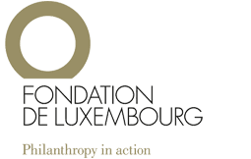

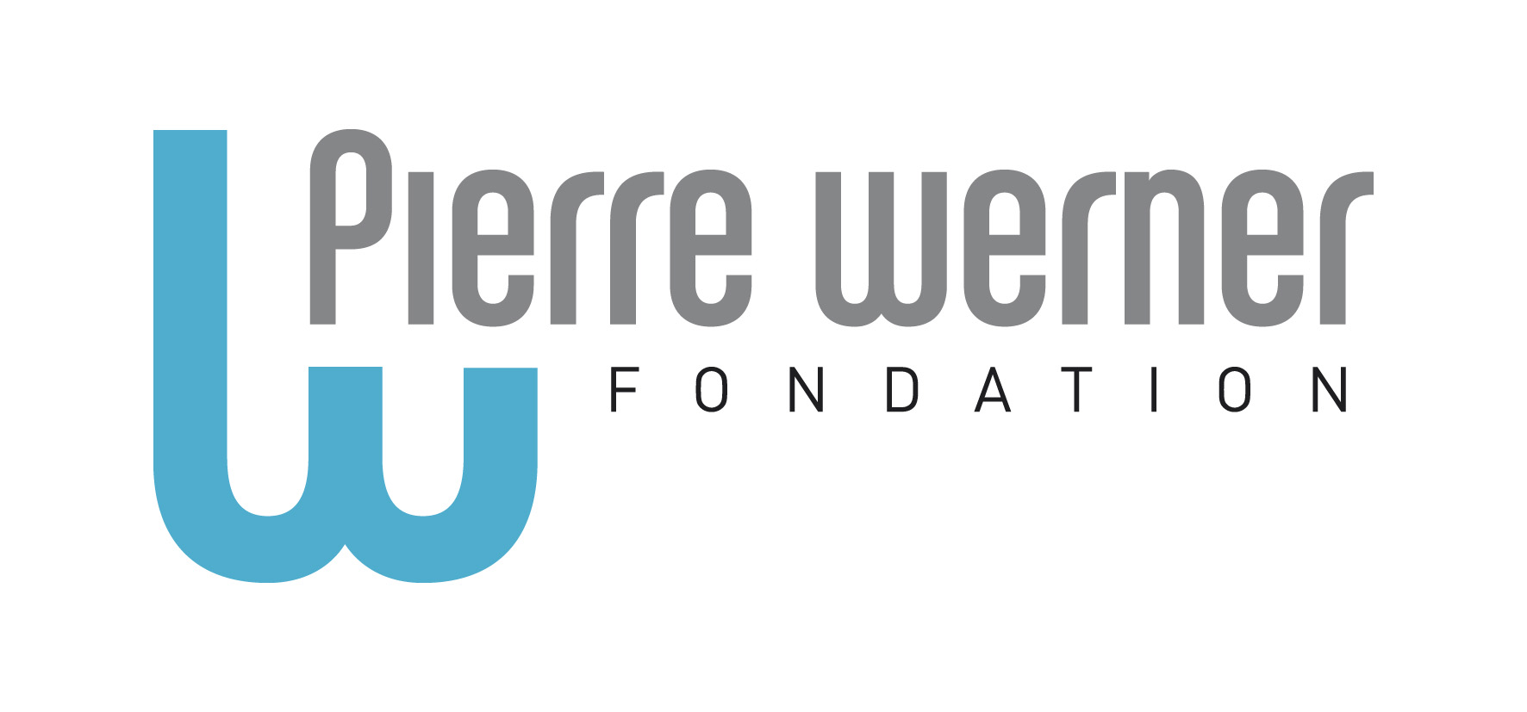

The Pierre Werner Scholarship
Application Form

- Applicant’s and institution’s details

Applicant’s details
Family name
Maiden Name
First name
Title
Function
Date of Birth
Gender
Nationality
Email address
Postal address
Telephone no

Institution details
Name of Faculty
Name of Research Unit
Name of other collaborating institution

- PhD research

Research domain
Main Domain
Sub Domain
Keywords (max. 6)

Master or PhD thesis
Title of thesis
Name of PhD supervisor
Start of PhD (month/year)
Date of thesis defense (if known)
Members of PhD defense committee (name & institution)

Please provide a lay abstract of your PhD thesis (400-600 words). Add separate page if need be.
[The Faculty of Law, Economics and Finance at the University of Luxembourg may use this abstract for communicating its research activities to the wider public].

Please list and describe in detail any other outcomes that have directly emerged from your PhD research work, e.g. monograph, book, conference, dissemination activities, collaborations, follow-up projects, etc.

The Pierre Werner Scholarship
Additional information Form

- Originality and potential of the research work

In which your PhD studies demonstrate the production of new knowledge?

In which your PhD studies demonstrate the innovative use of research methodologies:

In which your PhD studies has an impact on research paradigms:

In which your PhD studies has an impact on European society:

- Academic achievement

Academic achievement is counted only during the PhD studies (please fill in the relevant information in the column “your contribution”.

 | Example for Law | Example for Economics & Finance | Example for Political sciences | Your contribution
Number of publications written during PhD | article, book chapter, … | discussion papers, article, book chapter, … | discussion papers, article, book chapter, …
Overall quality of publications | Journal, Monograph, International recognition of Eds or Publisher | International Journal Ranking | International Journal Ranking
Personal contribution in co-authored publications | Evidence of % of scientific contribution in the work | Evidence of % of scientific contribution in the work | Evidence of % of scientific contribution in the work
Number of participations in international conferences | with paper | with paper | with paper
Teaching activities | including moot court coaching | evaluations by profs and students | evaluations by profs and students

- Relevance and impact of the research work to the promotion of the ideals of the Fondation Pierre Werner

In which your PhD studies promotes the ideals of the Fondation Pierre Werner (European unification, Monetary questions, Democracy in Europe, Human rights in Europe)?

- Language skills (particularly those of the University of Luxembourg)

Please indicate the number of spoken non-native languages (in conferences, …):

Please indicate the number of written non-native languages (in papers, …)

- Validation and signature

Terms and Conditions
The applicant declares that he/she has read the guidelines and that the given information is correct and complete.
The applicant declares to adhere to the rules of good research practice as outlined in The European Code of Conduct for Research Integrity. Incomplete and/or late applications will not be considered.

Applications are to be submitted to: pierrewernerscholarship@uni.lu

Deadline: March 25th 2024

Full name and signature Date

